

Energy Efficiency and Emissions of Optimizers: A deeper look into the hyperparameters of deep learning models

Md Asif Mahmod Tusher Siddique

Student ID: 77302132

# Abstract

Optimizers are important in the architecture of deep neural network models by governing the pace of the training and ultimate prediction performance. Even though a few works can be found in the literature on the performance in terms of accuracy comparisons amongst a few deep learning optimizers, in the absence of strong theoretical direction and convincing empirical research on the environmental and carbon footprint of the myriad of optimizers present today, research don’t consider energy consumption while choosing optimizer for deep learning models. So, this research investigates the critical comparative and scrupulous statistical analysis on the energy consumption and parallel environmental impacts of the deep learning optimizers. In total nine avant-garde optimizers are tested in this research to find the greenest deep learning optimizer. T-test is performed on the resultant energy consumption data to find if these results are statistically significantly different or not. The findings of this study show that disparate deep learning optimizers require varying amounts of energy to accomplish the very same objective. Moreover, this research reveals that SGD (Stochastic gradient descent) consistently outperforms other optimizers in terms of energy and carbon efficiency. It is also found that popular optimizers such as Adam, Adagrad, and AdaMax remain a competent choice while designing deep learning architectures. In conclusion, the results are encouraging, and the information gathered in this study may be utilized to visualize energy usage and environmental effect in future initiatives.

**Keywords:** *Optimizers, Deep learning, CNN, SGD (Stochastic gradient descent), T-test, Carbon footprint, Energy consumption, GHG emission*

# Table of Contents

Abstract 2

Table of Contents 3

1. Introduction 4

1.1 Scoping of the research 5

1.2 Aims and Objectives 5

1.3 Contribution of the research 6

1.4 Structure of the report 6

2. Literature Review 7

2.1 ICT and Environment 7

2.2 Machine learning and deep learning 8

2.3 Deep learning optimizers 8

2.4 Energy measurement tools 9

3. Methodology 10

3.1 Macro level methodology 10

3.2 Micro level methodology 11

3.2.1 Dataset 11

3.2.2 Convolutional neural network model 12

3.2.3 Optimizers 13

3.2.4 Environment Setup (Joulemeter) 19

3.2.5 Carbon Footprinting Tool 20

4. Results and Discussion 22

4.1 Statistical Analysis 32

4.2 T-Test 32

I. SGD and Adabound 32

II. SGD and Adagrad 33

III. SGD and Adam 33

IV. SGD and AdaMax 33

V. SGD and FTRL 34

VI. SGD and Nadam 34

VII. SGD and RMSProp 34

VIII. SGD and Adadelta 34

IX. Adagrad and Adam 35

X. AdaMax and FTRL 35

XI. Nadam and RMSProp 35

XII. SGD and Adadelta 36

4.3 Carbon Footprint 36

4.4 Validation challenges 38

5. Conclusion and Future Work 40

References 41

Appendix 45

# 1. Introduction

Machine learning has been gaining momentum for a while now. It is getting used in our daily routine life without us even noticing it, which was just a laboratory technology quickly converted to practical and eventually in our daily everyday lives. Machine learning has had a significant influence on computing science as well as a broad range of enterprises who work on statistics problems, like consumer services, complicated system fault diagnosis, and logistics chain management. Machine-learning algorithms are developed to analyse elevated observational evidence in novel ways, encompassing a wide range of outcomes across empirical disciplines, spanning biologists to astronomy to sociology.

Deep learning is a part of Machine learning/AI that enables computational models with numerous processing layers to learn different degrees of abstraction for data representations (LeCun et al., 2015). People are using Deep learning in everyday tasks such as Virtual personal assistants (Google assistant, Cortana, Siri, Alexa, etc.), Traffic predictions, surveillance via video, social media services, Spam/Malware filtering, recommendation systems and many others. The task of a Deep learning model is to mainly use an algorithm to extrapolate the data and generate predictions based on previously unknown data. Here optimizers are necessary to map the inputs to that of the yields. The work of an optimizer is just that, when translating inputs to outputs, an optimization method determines the value of the weights that slash the error. While implementing Deep learning models, selecting proper optimizer is crucial as it governs the pace of the training and ultimate prediction performance (Choi et al., 2019). Most of the studies on performances of deep learning models primarily concentrate on the accuracy of the model and the same is true for the studies on optimizers.

But considering the time it takes to train the Deep learning models, these models often use a lot of energy. While these implementations of Deep learning models may pay off financially, they also have a detrimental environmental consequence. Today’s deep learning models require a tremendous amount of energy, and their energy demands are rapidly increasing. As in deep learning age, the computing resources necessary to develop finest Ai systems have essentially doubled every 3-4 months. Recently OpenAI used 45 terabytes of data to train its GPT-3 model. Nvidia used 512 V100 GPUs over 9 days to train the final version of MegatronLM. A single V100 GPU may use anything from 250 to 300 watts. If we estimate a power consumption of 250 watts, 512 V100 GPUs will require 128,000 watts, or 128 kilowatts (kW). So, the training consumed 27,648 kilowatt hours (kWh) in total, whereas an average American household consumes 10,649 KWH annually (TechTarget, 2021). In a nutshell, AI already has a significant carbon impact, and if current trends resume, it will only become worse. Artificial intelligence might become an adversary in the battle against Co2 emissions in the coming years unless we are ready to examine and revise today's AI development program. One of the other problems is that recent advancements in AI technology are essentially obtained in today's deep learning-centric research paradigm by sheer enormity: greater datasets more computing. Which basically consumes enormous amounts of energy and thus contributes to carbon emissions. As the deep learning models are getting used more and more, we can estimate the scale of energy consumption required for all the future implementations of the machine learning models. According to a 2019 study (Strubell et al.) an individual deep learning model can contribute up to 626,155 pounds of CO2 emissions, which is about equal to the lifetime CO2 emissions of 5 automobiles and in a year an average American produces around 36,000 pounds of carbon. Though this is for one of the most energy hungry training of a ML model. One of the reasons behind the consumption of this much energy is the dataset. The other reason is the mathematical operations that need to be carried out (for forward and back propagation) for each and every data that is provided while training and revising their parameters. The intensive research and adjustment necessary to construct a model is another element driving AI's high energy consumption. Machine learning is still essentially a trial-and-error process today. During training, researchers will typically create hundreds of different versions of a particular model, experimenting with different neural architectures and hyperparameters until they find the best design. As we can see it is pertinent that AI/Machine learning practitioners consider the carbon footprint and climate impact of their research. In addition to performance metrics and accuracy measurements it is also important to provide statistics on the amount of energy used. Even though a more long-term fundamental shift is necessary, for now we can use more optimized hyperparameters such as efficient optimizers thus, maximizing the pace of the training and ultimate prediction performance. So, in this study we will do a deep dive into these optimizers and try to present an overview of the energy consumption and emissions related to these deep learning optimizers.

## 1.1 Scoping of the research

This experiment examines different deep learning optimizers in order to find the power consumption contributed by each optimizer, thus environmental impact of these optimizers. These studies are focused on analysing energy usage in a case study using optimizers, offering a viewpoint and benchmark information to display power use and carbon emissions effect in a deep learning model. As a result, the focus of this study will be on assessing deep learning optimizers affects electricity consumption while utilized independently. However, this study does not consider those real-world scenarios where a few deep learning models are run together, thus might use many different optimizers simultaneously at an individual program.

## 1.2 Aims and Objectives

The aim of this research is to investigate the GHG emissions and energy consumptions of different optimizers used in convolutional neural network models. The aim is supported by following list of research objectives and research questions:

**RO1:** Assess the environmental impact of ICT and more specifically machine learning and AI.

RO 1.1 Literature review on ICT, sustainability, and Green Networking

RQ 1.2 Critical overview of research on power usage and GHH emissions of deep learning and ML models.

RQ 1.3: Conduct a systematic literature overview of the efficiency and power usage of deep learning optimizers.

**RQ 2:** How much energy each of the deep learning models with selected optimizers are using?

RO 2.1: Implement deep learning model with selected optimizers

RO 2.2: Measure the energy consumption and effect of each optimizer using the Joulemeter software

**RQ 3:** What is the carbon footprint of the models with each optimizer?

RO 3.1 From the collected data of energy consumption approximate the carbon footprint

RO 3.2 Audit the sustainability aspect of each of optimizers

**RQ 4:** Are these results statistically different from one another? / Is there any statistical significance? / Perform statistical analysis to draw conclusions and make recommendations.

RO 4.1: Perform a series of T-test analyses whether the results are significantly different from one another/ test whether the best performing optimizer is actually significantly efficient.

## 1.3 Contribution of the research

The power usage analysis of optimizers used in deep learning models has not been studied before. Moreover, to accurately examine the performance and accuracy, the energy consumption aspect of the optimizers in deep learning models may hold a crucial influence. In brief, the contributions of this thesis are:

* Investigated the energy consumption of deep learning optimizers and Open-source technology, resources, and frameworks were used to formulate and develop the project.
* Analysed the carbon footprint of each of corresponding optimizers
* Statistically analysed the significance and correlation of the results

## 1.4 Structure of the report

This thesis report is mainly divided into five parts. The structure of report by each chapter is given below:

**Introduction:** In this chapter the important background of deep learning optimizers, the scope of the research, the aims and objectives and contribution of this work is given.

**Literature review:** a systematic literature overview of Information and communication technology, and nature and all the related works done on optimizers used in deep learning models.

**Methodology:** This chapter is divided into the micro and macro level methodology that is followed in this research to assess the environmental impact of deep learning optimizers.

**Results and discussion:** The result analysis of the data obtained from the experiments using pertinent performance and energy indicators, as well as the inferences that were made.

**Conclusion and future work:** In this chapter the outcome of the research is discussed along with the probable direction of the further research.

# Literature Review

## 2.1 ICT and Environment

ICT is seen as a critical component in the 'information revolution,' which refers to developments in the global economy. The information and communication technology field is among the world's quickest rising Green-house-gas spewing industry in the world (Magazzino, et al., 2021). The ICT industry accounts for 2% of worldwide carbon dioxide emissions, whereas the other 98 percent is accounted for by other fields such as healthcare, transport, educational, and others (Webb et al. 2008). Because of growing international need of Information technology commodities, the Information and communication industry can have a pivotal role in mitigating emissions of carbon dioxide through reducing the carbon imprints of its goods and products. Especially given the fact that much research has been done to make semiconductors as well as other microcontrollers more environmentally friendly (Simunic et al., 2001; Schmitz et al., 2004; Hosangadi et al., 2005; Shiri et al, 2020). The cost of delivering power for systems of storage equipment for example cloud data centres, computers, and other portable hardwares is said to be influenced by power generation (Fettweis & Zimmermann, 2008). The aggregated power utilised by computers as well as networking systems contributes for around 8% of all electricity consumed worldwide (Jörg, 2013).

According to John Houghton, ICT has both beneficial and harmful environmental consequences. In simple terms Green IT can be defined as techniques for lowering power consumption and the ecological effect of systems, infrastructure, goods, and processes. A deeper definition of Sustainable IT, on the other hand, includes initiatives that address environmental and social challenges (BCS, 2012). According to Bittencourt Dolci et al. (2015), Green Information Technology plays a significant part in improving an organisation's status quo by integrating resources available, sustainable regulations, as well as initiatives on the economy to provide advantages to the climate plus enterprises. This is echoed by Khan et al., (2015) who 'considers the triple bottom line' (economical, ecological, and social) as well as the overall effectiveness, all of which are linked with SMARTER2030 efforts.

## 2.2 Machine learning and deep learning

The study of enabling robots to operate without being directly instructed is referred to as Machine Learning. Machine learning study and AI mainly focuses on computers' capacity to learn, that is defined as gaining knowledge via learning plus retrieving relevant aspects from previously collected info. Techniques for deep learning are utilised in a variety of areas, spanning healthcare and monitoring equipment, when classical methods are difficult or impossible to design to accomplish the essential tasks (Zhang, 2020). Machine learning offers a variety of implications in ICT, including self-driving cars, speech recognition, and fast web search (Dimitrova & Dimitrovski, 2020). Machine learning models consume quite a lot of energy while training, and are very power hungry (The conversation, 2020). But according to García-Martín et al (2019), there are not enough techniques to compute and develop energy models in current ML frameworks, thus measuring energy usage is very challenging. They also performed research on works done on energy measurement, assessment, and administration and divided the works into 4 clusters: (i) publications that employ performance counters to get the activity components and then employ regression analysis or inferential statistics approaches to get the electricity consumption, (ii) articles that get the engagement factors from simulation studies. (iii) articles that give power or energy projection in real time; (iv) studies that provide architectural or instruction level information. As per García-Martín et al (2019) The bulk of publications assessed used performance counters (PMCs) to acquire the computing activity factors, which were subsequently used to construct the model utilising regression approaches (Bellosa et al., 2003; Bertran et al., 2010; Economou et al., 2006; Gilberto and Margaret, 2005; Goel and McKee, 2016). Many other models got their results via simulation (Brooks et al., 2000; Joseph & Martonosi, 2001; Lee & Brooks, 2006; Li et al., 2009; Sami et al., 2002; Rethinagiri et al., 2014). A limited number of the articles provide architecture-level estimation (Laurenzano et al., 2014; Mazouz et al., 2017; Sami et al., 2002). Mazouz (2017) proposes a method for modelling energy use at the architectural and instructional levels. All models that use performance counters to get activity components provide for assessment of energy in real-time. The reasoning behind this is because addressing certain registers has no substantial overhead (Brooks et al., 2000; Bertran et al., 2010; Economou et al., 2006). Here, Economou et al., (2006) require offsite measurement step to retrieve the variables of the model, however this is often done just once per system.

## 2.3 Deep learning optimizers

Optimizers chosen in deep learning models play an important role. But till now, there is no notion that fully explains how to make this decision, nor any studies on the energy consumption of deep learning optimizers. We alternatively depend on benchmarking (Schneider et al., 2019) and empirical research (Wilson et al., 2017). According to Choi et al. (2019) the hyperparameter search space might be the singular most relevant element in understanding the results of current empirical literature evaluations. Wilson et al. (2017) assembled an interpretive binary stratification problem with linearly separable data, also investigated the empirical generalisation capabilities of adaptive approaches on disparate modern deep learning models and concludes that Adaptive methods performs worse than SGD or gradient descent. Schneider et al. (2019), represented DEEPOBS, a benchmarking technique for optimizers of deep learning models and concluded: Some optimization techniques might well be able to extend faultless scaling over numerous models and data sets in a congruous manner. Okewu et al. (2019), used py neural learning libraries to run a number of tests and compared stochastic optimizers in relation to the learning time convergence rate. Postalcıoğlu (2020), experimented ADAM (Adaptive moment estimation), Stochastic gradient descent with momentum (SGDM), and Root mean square propagation (RMSProp) on Fruits image dataset and compared final validation accuracy. A plant disease classification using different CNN and disparate optimizers of deep learning models was done by Saleem et al., (2020). Here, they compared Validation accuracy and F1 score of these models & optimizers. Perin and Picek (2020), performed investigation on optimizers of deep learning models on side-channels evaluation after that deduces that, although standard optimizers like Adam and RMSprop perform good, these are prone to overfitting, necessitating the usage of brief training phases, tiny profile models, and strict regularisation. Schmidt et al. (2021), carried out an extensive (More than 50,000 individual runs) scrutiny on popular 15 deep learning optimizers and provided three conclusions: (i) The performance of the optimizer varies substantially depending on the workload. (ii) Default settings perform similarly to changing a single uniform optimizer's hyperparameters. (iii) While no single optimization method evidently dominates across all tasks, a smaller subset of particular optimizers and parameter selections that consistently produce promising results. This comprehensive literature review reveals that no research has been done on the power and GHG emissions of deep learning optimizers.

## 2.4 Energy measurement tools

According to Vijayaraghavan & Dornfeld (2010), there are a profusion of power profiling technologies available today that can observe, and record power of a device use in buildings, helping businesses to save money on power bills. Kansal et al. (2008) resonates that in his article saying a lot of software energy monitoring solutions are widely accessible today due to high energy expenditures connected with delivering computer resources and lowering ICT's impact to global warming. A software developed by Microsoft named joulemeter is commonly used for a while to monitor energy consumption on a PC. Joulemeter can track system resources like CPU use, disc usage, and monitor brightness to calculate the computer's power consumption. Then, using automatically trained realistic power algorithms, translate these numbers to power utilisation (Goraczko et al, 2010). Joulemeter may be utilized to get info of power usage, energy management, as well as provisioning factors in data centres, consumer computing, and equipment architectures (Kothari & Bhattacharya, 2009). Another software named Power Gadget by Intel is also commonly used in much research. On Windows and macOS, it comprises a driver, a program, and frameworks for measuring and analysing concurrent-time power data utilising the CPU's energy sensors (Aqib and Fouz, 2016). According to Yi et al. (2014) Power Gadget was created to give both users and developers exact power usage statistics, delivering a range of data stretching from processor. However, Power Gadget does not have an application specific energy consumption technique, for that reason in this experiment joulemeter by Microsoft is used.

# Methodology

## 3.1 Macro level methodology

In this experiment, A Life Cycle Assessment (LCA) paradigm is considered as a macro methodology to transmit research of analytics for power usage as well as carbon emit of disparate deep learning optimizers. As shown in figure below, LCA may be used to assess the environmental impacts of resource inputs and outputs, such as electricity consumption and environmental pollution, across the course of a project's life cycle. It covers all four stages of the life cycle, including acquisition of raw materials (RMA), manufacturing, application, and end-of-life treatments (EoLT). In this study, the ICT LCA implementation studied is the measurement of power usage and the assessment of an ecological effect, specifically the GHG output of nine deep learning optimizers and a comparison between them. LCA mainly consists of 6 different stages. Description of each stage and its implementation is given below:

**General requirements:** The evaluation of high-level requirements of life cycle phases in the context of the problem is the major focus of the first phase of LCA. The 9 deep learning optimizers were explored in this experiment for this stage.

**Scope Definition:** At this step, goals are specified, including system boundaries, components, rationale for carrying out the research, the target demographic, and data integrity. In the introductory portion of this study, we stated our objectives and scope.

**Life cycle inventory:** This step of the LCA is primarily concerned with presenting inventory in order to gather, allocate, and calculate data. This stage will be illustrated in the micro methodology, results, and discussion portions of this experiment.

**Life cycle impact assessment:** This phase is mostly concerned with assessing environmental consequences of the technology. This will be elaborated in the carbon footprint calculation of results and discussion stage.

**Life cycle Interpretation:** In this stage the results of the LCIA & LCI are combined to interpret questions posed at the target description, evaluate evidence, discern limits, as well as provide suggestions.

**Reporting:** This is the final stage of the life cycle assessment and in this stage all the requirements are summarised and reported. In this research this section of the life cycle assessment will be done on the conclusions and future works section.

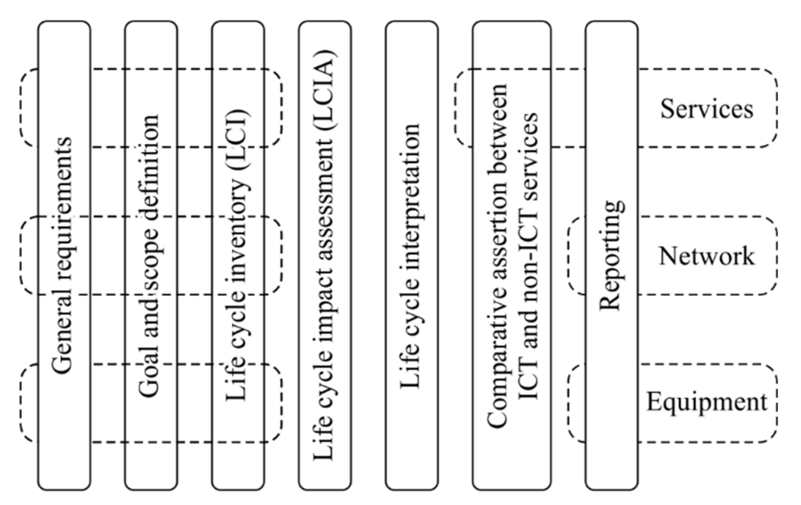

*Figure 1: LCA Methodology specification*

## 3.2 Micro level methodology

In this section we have detailed the dataset, the selected convolutional Neural Network model on which the experiments will be conducted, Optimizers that will be tested, calibration and environment setup of joulemeter and overall experimental design.

### 3.2.1 Dataset

The dataset selected for the analysis in this experiment is collected from the Kaggle (Plant Village Dataset). A few modifications have been done on the dataset to fit the needs of this experiment. Original dataset contained a total number of 20,639 images of 15 classes, which included data of Tomato, Pepper, and Potato leaves. For this experiment 4 classes of diseased tomato leaves were chosen. Name of the disease classes are tomato bacterial spot, tomato yellow leaf curl virus, tomato bacterial spot, healthy leaves, and leaf mould. Description of each disease class is given below:

|  |  |  |  |  |  |  |
| --- | --- | --- | --- | --- | --- | --- |
| Label | Category | # Samples | # Training samples | # Testing samples | Symptoms | Illustration |
| 1 | Bacterial Spot | 792 | 633 | 158 | Spots range in colour from dark brown to black, and they rarely grow larger than 3mm in diameter. |  |
| 2 | Healthy | 1063 | 850 | 212 | New leaves can be 3 inches long and have a bright green colour. Grown leaves are normally 10 inches long. |  |
| 3 | Leaf mold | 952 | 761 | 190 | Small pale greenish-yellow patches, usually less than.25 inch in diameter. On the lowest half of the mould is an olive green to brown velvety mould. |  |
| 4 | Yellow leaf curl virus | 1152 | 921 | 230 | Stunting, reduced size of leaf, skyward cupping or leave curls, and chlorosis on flowers & leaves are all symptoms of severe stunting. |  |

*Table 1: Description of the dataset and disease classes*

In this experiment 80% data is used for training the model. A few steps are followed at the beginning of the experiment to properly prepare the images for the model. Firstly, the images are loaded from the different folders and labelled by the folder names. These images then shuffled to properly randomise the data. Then the images are resized to 40*40 to be used in the CNN model.

### 3.2.2 Convolutional neural network model

After the debut of AlexNet in 2012 (Krizhevsky et al.) deep convolutional models have achieved an extraordinary advancement in the computer vision department. Later a lot of deep learning models has been introduced like VGG (Simonyan and Zisserman, 2014), ResNet (He et al., 2016), MobileNet (Howard et al., 2017), OverFeat (Sermanet et al., 2013), Inception (Szegedy et al., 2017), ZFNet (Zeiler and Fergus, 2014), etc. To gain better/more results for categorising computer vision issues, certain researchers provided enhanced/modified versions of cutting-edge CNN models, including GoogleNet (Szegedy et al., 2015), Cifer (Zhang et al., 2018), etc. A few hybrid architectures can also be found in a few literatures like ArgoAVNEF (Chavan and Nandedkar, 2018), which is the combination of VGG (Simonyan and Zisserman, 2014) and AlexNet (Krizhevsky et al.) models, combination of AlexNet and GoogleNet (Liu et al., 2017). For this experiment a CNN model named DenseNet 121 is used which was first introduced by Huang et at. (2017). DenseNet is mainly a CNN with deep interconnections among stratums. In a feed forward approach, it simply ties every level to the one before it. This network features L(L+1) direct interconnections among each layer and its succeeding layer, whereas other standard convolutional networks only have one link among every layer to its next layer. The DenseNet 121 design offers several advantages, including alleviating the vanishing-gradient problem, bolstering feature propagation, and, most importantly, decreasing the quantity of hyperparameters. At the network model we are using 15 dense layers, a learning rate of 0.01, activation function named ‘softmax’, and ‘accuracy’ metrics.

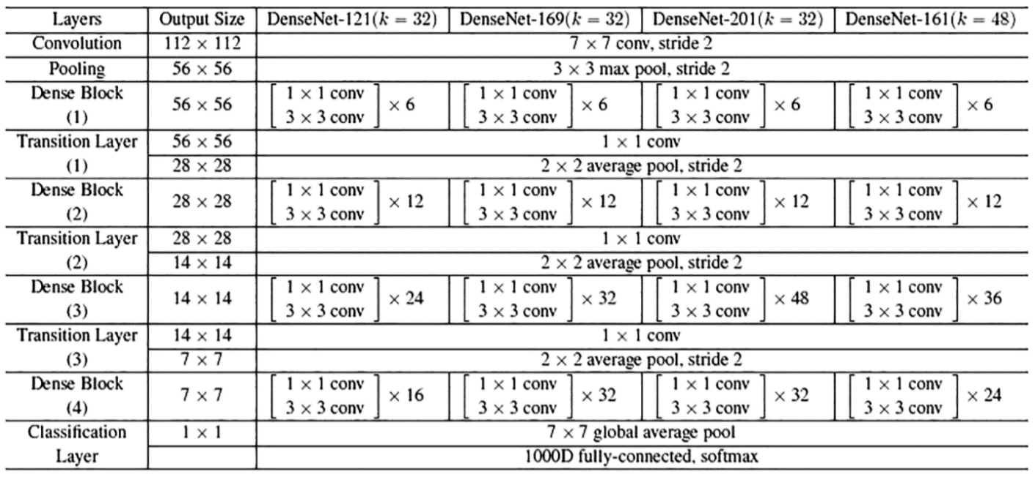

*Figure 2: Architectures of DenseNet models (Yong and Ming, 2020)*

### 3.2.3 Optimizers

A Convolutional Neural Network model is usually edified by changing the hyperparameters of all deep learning layers iteratively in the network, in that an optimizer plays a key part. These optimizers are conventionally interpreted with the rule they update by, and that is typically maintained by hyperparameters which ascertains its behaviour. The assumption that the objective function J(θ) can be invertible, plus hence that one can compute each point gradient to determine the optimal, is a popular misconception in machine learning. Gradients, more exactly, point toward greater values, hence, to obtain the minimum value, we must examine the gradient's inverse. At each cycle, the intended and predicted outcomes are assessed, and the mistake is backpropagated. Gradient descent can be used as a first-order optimization technique in the setting of unconstrained optimization. We perform steps proportionate to the inverse of the function's gradient at the present position to obtain a local minimum. Cross entropy is among the most frequently used performance measuring metrics. While intended and expected outcomes are same precisely, the value of the cross-entropy is close to zero, and this is among fundamental goals of any optimization strategy. In this experiment we have considered 9 mostly used optimizers, description of these optimizers is given below,

#### SGD:

Stochastic gradient descent (SGD) is among the most basic optimizers of deep learning models. For all hyperparameters a constant rate of learning is required during the train period, plus it’s a quick convergence ability. It’s a stochastic estimate of the gradient descent technique which minimises a sum of convex functions as the optimal solution. SGD minimises processing cost by sampling an instance i ∈ 1, . . . , N at arbitrary plus computes the gradient to upgrade at each iteration (one of parameters θ for each sample at each step t). The loss function may see huge swings as a result of the rapid updates with a high variance for SGD. The weight update of the SGD is done through the following equation:

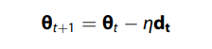

Here, for the learning rate η at every moment t, dt is the objective function’s gradient. Instead of updating the hyperparameters with a single example, we may do it with a defined quantity of these: a mini batch. For such an instance, it’s about SGD mini-batch production. At this form of gradient descent, in the place of using every data of training, just a part data is used to generate the function of loss. As here we're only utilizing a portion of sample instead of complete population, we'll need lesser rounds. In consequence, the mini batch approach beats algorithms that combine stochastic and batch gradient descent. Compared to prior descent of gradient versions, current method can be more advantageous plus dependable. Since the approach uses batching, the system can save time by not having to store all of the training data in memory. Mini-batch gradient descent's computational complexity is also coarser than group gradient descent's but smoother than stochastic gradient descents.

#### Adagrad:

Adaptive gradient descent differs from conventional gradient descent methods in a few ways. This is due to the fact that every step utilises a disparate rate of learning. Difference of the parameters during training determines the change in learning rate. The smaller the variations in learning rate, the more the parameters change. As real-life samples have both crowded and scattered features, this change can be quite advantageous. As a result, having the same learning rate value for all characteristics is unjust. The weights are updated by the Adagrad algorithm using the formula below. The update of weights in Adagrad is done through the following equation:

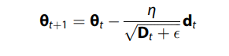

Here, to steer clear of division by small numbers Є is the vector, and at each timestamp t with respect to θ, Dt is the diagonal matrix, which is the summation of squared gradient estimate. The benefit of Adagrad would be that it avoids the need to fine-tune the learning rate directly. It’s extra trustworthy than gradient descent methods and their parts, plus it achieves faster convergence. A downside of the AdaGrad optimizer would be that it cuts the learning rate brutally and continuously. It is possible that the learning rate slows to a crawl. That's the consequence of the gradients square at the basement slowly building up, rising the component of the denominator. As a consequence of low learning rates, the architecture eventually becomes unable to acquire new information, compromising the model's accuracy.

#### Adadelta

AdaDelta is a more powerful variant of the AdaGrad optimizer. It comes into picture to improve the major shortcomings of AdaGrad optimizer which decreases the learning rate kind of monotonously. The fundamental disadvantage of the Adagrad is the starting rate of learning needs to be set dynamically. The result of which is, after few steps, the architecture can no longer accumulate more information. Adadelta collects previous gradients using fixed size windows, whereas Adagrad gathers all past squared gradients for changing the rate of learning. Total gradients are treated like decreasing mean of previous square in this case. As a result, at each time, concurrent mean rely on prior mean and the concurrent gradient, which is shown in the following equation:

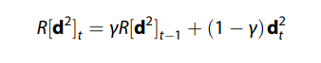

In this equation γ represents constant of decay with a value of 0.9, so the update of Adagrad can be rewritten as:

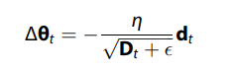

Here, the decaying average over prior squared gradients are substituted by the diagonal matrix equation. Following equation of RMS (root mean squared) fault of gradient is the denominator term. Identically, the root mean square errors of parameter updates are substituted by the RMS errors.

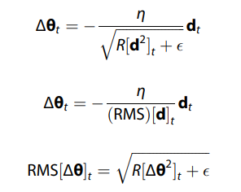

In here R[Δθ2]t indicates the frequency of squared parameter changes those decays exponentially, which is shown in the following equation:

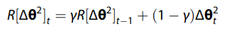

Because RMS[Δθ]t for the current time step is unknown, the preceding update rule using RMS is used to construct the Adadelta update term in the final equation.

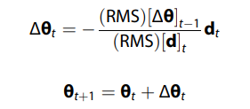

#### RMSprop:

Among deep learning aficionados, RMS prop is a prominent optimizer. This might be due to the fact that it has no article even though popular with the developers. RMSprop is a natural continuation of RPPROP's model. Fault of gradients fluctuation is solved by RPPROP. The issue with the gradients is many were modest while others may be rather big. The result of which is, establishing only a rate of learning might not be the ideal option. Its scaling factor for every weight is adjusted by RPPROP depending upon that gradient's polarity. In this procedure, the 2 gradients will be first assessed for significance. If those share a similar significance, designers can reduce the size of the steps by a modest amount. Should these show different indications, designers need to make the levels smaller. Then we restrict the size of steps, and weight needs to be updated. One problem of RPPROP is that this doesn't scale well with big samples or mini-batch upgrades. The primary purpose of RMS prop's expansion was to accomplish both RPPROP's resilience as well as the effectiveness of mini batches at the very same moment. As these decreases continuously falling rate of learning, RMSprop can be considered an improvement of AdaGrad. Its primary goal of the approach is to speed up the optimization method through limiting the number of objective functions required to attain the solution space. The rule of component update of RMSprop is showed by the following equation:

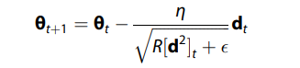

To put it another way, if there exists a hyperparameter that effects the function of cost to fluctuate a lot, we should penalise updating that value. Assume you've created a model to classify a wide range of fish. To distinguish between the fishes, the model depends mostly on the component 'colour.' The result of which is, it makes many mistakes. RMS Prop penalises 'colour,' allowing it to depend on the rest of the attributes as well. When compared to previous versions of gradient descent methods, this technique offers significant advantages.

#### Adam

Adaptive moment estimate is the source of the word Adam. This optimization method is a development of stochastic gradient descent for updating network weights during training. Unlike Stochastic, Adam modifies the rate of learning of every layer value independently, instead of continuing a particular rate of learning for the entire training. Adam optimization algorithm's authors are familiar with the benefits of RMSProp and Adagrad, that are both SGD variants. As a result, both RMSprop and Adagrad’s characteristics are inherited by the Adam optimizer. Rather than using the mean like in RMSProp, Adam employs integrands of gradients to modify learning rates. We take the 2nd instant of gradients to imply the varied variance. Moreover, Adam provides several benefits, that’s why it is so extensively employed. It’s commonly used as a standard for deep learning articles plus is suggested as the standard optimization method. Furthermore, it is method is easy to employ, along with less time of execution, decreased memory utilization, plus demands less tweaking than most others. Weight update rule of the Adam optimizer is given by the following equation:

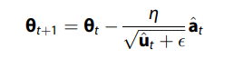

Here, mean of previous gradient (at) plus previous gradient square is given by:

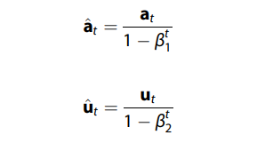

Adam leverages most good features of all the others still not used always. This is due to the fact that even Adam has certain flaws. It prioritises quicker calculation time over data points, whereas algorithms such as SGD prioritise points of data. As a result, SGD and similar algorithms generalise samples more effectively at the expense of slow calculation speed.

#### Adabound

The Adabound stochastic optimizer is a variation of the Adam stochastic optimizer that is supposed to be more resilient to high learning rates. On learning rates, dynamic limits are used, in which the lower and upper bounds are initially set to 0 and infinity, respectively, and then progressively converge to a uniform final step size. At the start of training, Adabound can be considered an adaptive approach, but as the time step rises, it progressively and seamlessly converts to SGD (or with momentum). The Adabound optimizer can be expressed via the following equation:

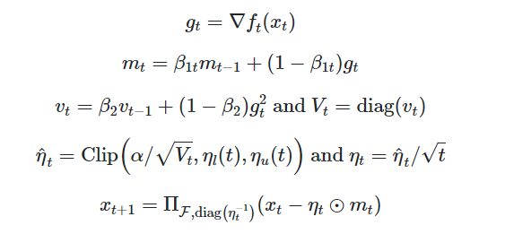

Here, in these equations α represents the starting step size and two versions of η indicate the higher and lower bounds of functions.

#### AdaMax

A slightly contrasting version of Adam which was presented by Zeiler (2012). It is founded upon the unbounded normative plus maybe used in the case of scarce hyperparameter upgrades such as word representations. In general, with each component inside the optimization problem, AdaMax adapts a variable step size autonomously. The update rule of the weight of AdaMax is given by substituting Adam’s lower part of of the weight update function, which is:

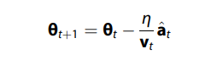

Where,

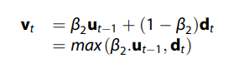

#### Ftrl

Ftrl optimizer as presented by McMahan et al. (2013) is mainly an optimizer that utilises the Ftrl algorithm. This method is inspired by the continuous learning process seen in online learning. In this scenario, an online participant loses every round after making a decision. The selection set, in essence, is a convex set in Euclidean space denoted by K∈Rn, and the losses are convex functions over K. In theory, the online player picks wt∈K at every iteration t and bears a loss ft(wt). If we have a T-round game, the player's purpose is to minimise his regret in relation to the optimal option in hindsight:

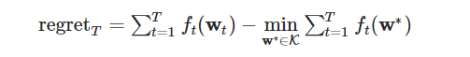

A successful strategy, intuitively, should result in a regret that is sublinear as a function of T. The most straightforward strategy is to pick the best option in hindsight at any moment.

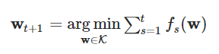

#### Nadam

Nadam or the Nesterov-accelerated Adaptive Moment Estimation algorithm adds Nesterov's Accelerated Gradient (NAG) or Nesterov momentum, which is a better form of momentum, to the Adam process. The Nadam is an expension of the GD technique in a broader sense. Even though a similar version of the article was written in ‘Stanford project report’ in 2015, Nadam algorithm was mainly presented by Timothy Dozat (2016). The weight equation of Nadam can be generated by expanding Adam’s equation of weight, which can be written as:

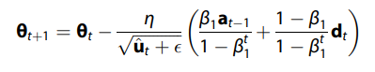

Here, inside the bracket the first part is an estimate of the preceding time step's momentum vector that has been adjusted for bias, so it can be replaced by the following equation:

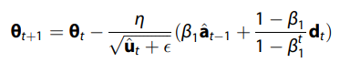

By substituting the bias-corrected estimate of the prior momentum vector with the bias-corrected estimate of the present momentum vector, the Nadam update rule is obtained, which can be expressed by:

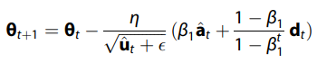

### 3.2.4 Environment Setup (Joulemeter)

Experimental setup influences the test results a lot, that’s why all the experiments were done on a specific laptop. The system that was used for the experiment had the following configuration:

**Model:** MSI Modern 15 b4m

**Processor:** AMD Ryzen 5 4500U with Radeon Graphics 2.38 GHz

**RAM:** 16 GB DDR4 3200 MHz

**Storage:** 512 GB Kingstone OM8PCP3512F + 512 GB Samsung MZVLQ512HALU

**Operating System:** Windows 11 Pro, Build 22000.613

**Power delivery:** 65 watts

**WAN:** Intel(R) Wi-Fi 6E AX210 160MHz

All the power consumption data was collected by Joulemeter, which was downloaded from the official Microsoft site ([www.microsoft.com/en-us/research/project/joulemeter](http://www.microsoft.com/en-us/research/project/joulemeter)). Windows 11 operating system lacks the capability of calibrating joulemeter. So joulemeter software in the laptop was manually calibrated using the joulemeter user manual. Manual calibration information is given below:

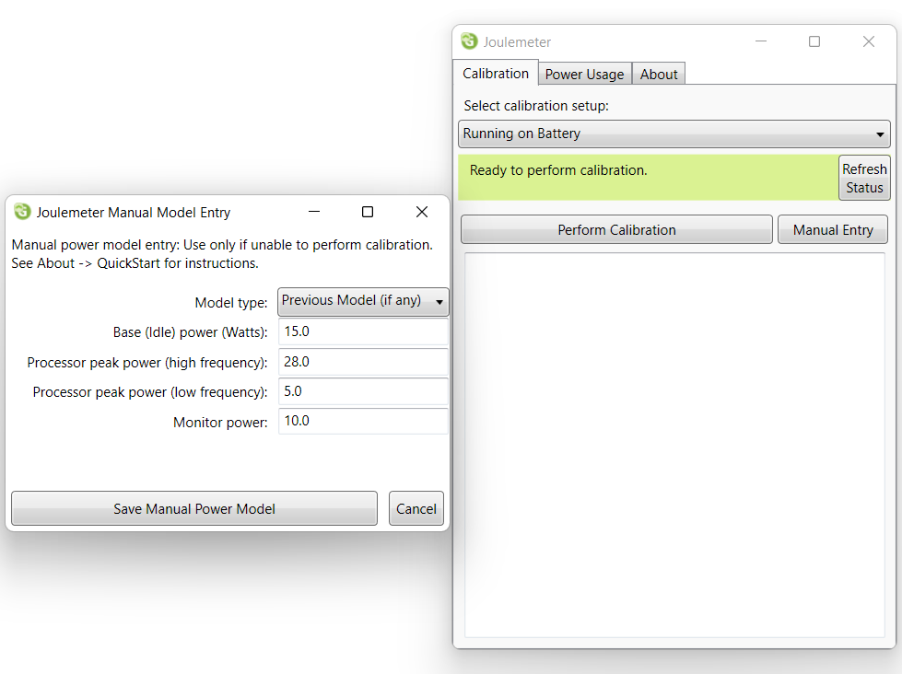

*Figure 3: Joulemeter calibration*

All the deep learning codes with the optimizer were implemented on the Jupyter Notebook of Anaconda. Python 3.9.7 version that was used in all of the experiments. After calibrating the joulemeter to collect the data the program that was executing while running the code was grabbed then the exe file name is given as an input in the joulemeter power usage tab. For this specific experiment python.exe was grabbed from the task manager to be given as input to the joulemeter. Then a new file was created using the Browse button present in the power usage tab. After that while running the experiment the data of power usage was collected and saved in that newly created file. Each of the optimizers was trained for 5 times and all the power consumption data was saved separately which is combined in the later stages of the experiment.

### 3.2.5 Carbon Footprinting Tool

The power usage data is converted to the amount of carbon emitted to the environment in the next stage of the experiment. For this experiment most recent DEFRA Conversion factors from the UK government were used, which is commonly used by UK govt. and international organisations to estimate GreenHouse Gas emission. According to the article there are 3 types of emissions: (i) Direct emission (Scope 1), or emissions that are produced by activities that a company owns or controls, (ii) Energy Indirect (Scope 2), or emissions that are the gases disparaged in the environment as a consequence of buying of power. These indirect emits are a consequence of a company's energy use, but they come from sources a person doesn’t own or control, (iii) Other Indirect (Scope 3), are emissions that are the result of someone’s action but not owned by that person and are not in the energy indirect emission. Scope 3 emissions include non-owned business travel, trash disposal, fuels, and goods purchased by your company. Other indirect emissions might come from actions both upstream and downstream of your company. As we are mainly using a laptop and consuming power from the UK grid, for this particular experiment emissions of scope 2 and 3 are considered, which mainly considers the United Kingdom electricity.

|  |  |  |  |  |  |  |  |
| --- | --- | --- | --- | --- | --- | --- | --- |
| Activity | Country | Unit | Year | kg CO2e | kg CO2 | kg CH4 | kg N2O |
| Electricity generated | Electricity: UK | kWh | 2021 | 0.21233 | 0.21016 | 0.0008 | 0.00137 |

*Table 2: UK govt. GHG emission factors for electricity*

# Results and Discussion

Results collected from the 90 runs of experiments (10 iterations for each optimizer) done in this research are discussed in this section. The following tables show the total amount of energy consumed at each iteration. Here, the power consumption value of CPU, Monitor, Disk, Base is the sum of total energy consumed at each iteration, which is added up to calculate the total energy used by all the hardware. Application energy consumption number is also the summation of all energy consumed at each iteration of the experiment. Total power consumption is the product of total energy used by hardware and application. Time value obtained from Joulemeter software is in microseconds which is converted to seconds here. Then the total energy consumption value which is in watts is converted to KJ (kilojoule), from this the value of average energy consumption per second is extracted. Aggregate average energy consumption value is the division summation of entire power consumption (KJ) with total time.

|  |  |  |  |  |  |  |  |  |  |  |  |
| --- | --- | --- | --- | --- | --- | --- | --- | --- | --- | --- | --- |
| Optimizer | | SGD | | | | | | | | | |
| Experiment No | | 1 | 2 | 3 | 4 | 5 | 6 | 7 | 8 | 9 | 10 |
| Hardware Power Consumption (W) | CPU (W) | 6306.4 | 6505.4 | 6573.5 | 6624.2 | 6721.2 | 6784.3 | 6028.8 | 6131.7 | 6288.4 | 6700.8 |
| Monitor (W) | 690 | 715 | 750 | 797.5 | 847.5 | 725 | 675 | 695 | 697.5 | 757.5 |
| Disk (W) | 8.2 | 5 | 14.2 | 4.9 | 7.3 | 11.9 | 6.8 | 7.8 | 9.2 | 13.5 |
| Base (W) | 4140 | 4290 | 4500 | 4785 | 5085 | 4350 | 4050 | 4170 | 4185 | 4545 |
| Total Hardware Power (W) | 11144.6 | 11515.4 | 11837.7 | 12211.6 | 12661 | 11871.2 | 10760.6 | 11004.5 | 11180.1 | 12016.8 |
| Application (W) | | 5577.7 | 5898.1 | 5904.1 | 5990.7 | 5949.4 | 5038.3 | 5297.4 | 5377.5 | 5180.2 | 5313.2 |
| Total Power Consumption (W) | | 16722.3 | 17413.5 | 17741.8 | 18202.3 | 18610.4 | 16909.5 | 16058 | 16382 | 16360.3 | 17330 |
| Total Time (s) | | 318.221 | 317.76 | 332.531 | 352.291 | 374.763 | 353.352 | 309.015 | 321.009 | 342.065 | 355.353 |
| Total Energy Consumption (KJ) | | 5321.387 | 5533.314 | 5899.698 | 6412.506 | 6974.489 | 5975.006 | 4962.163 | 5258.769 | 5596.286 | 6158.267 |
| Average Energy Consumption per second (J/s) | | 16722.3 | 17413.5 | 17741.8 | 18202.3 | 18610.4 | 16909.5 | 16058 | 16382 | 16360.3 | 17330 |
| Aggregated Average Energy Consumption per second (J/s) | | 17205.47766 | | | | | | | | | |

*Table 3: Power Consumption of SGD (Stochastic Gradient Descent) deep learning optimizer*

The table 2 above shows the power consumption at each iteration of Stochastic Gradient Descent. The aggregated power consumption for SGD is 17205.47 J/s.

|  |  |  |  |  |  |  |  |  |  |  |  |
| --- | --- | --- | --- | --- | --- | --- | --- | --- | --- | --- | --- |
| Optimizer | | Adabound | | | | | | | | | |
| Experiment No | | 1 | 2 | 3 | 4 | 5 | 6 | 7 | 8 | 9 | 10 |
| Hardware Power Consumption (W) | CPU (W) | 7349.8 | 5510.8 | 8152.9 | 7138.7 | 7349.8 | 7486.2 | 7832.3 | 9277.7 | Error | Error |
| Monitor (W) | 760.2 | 567 | 1630 | 728.7 | 760.2 | 885 | 942.5 | 1595 |
| Disk (W) | 12.3 | 18.5 | 43.3 | 18.2 | 12.3 | 8.7 | 12.7 | 11.9 |
| Base (W) | 5430 | 4050 | 9435 | 5205 | 5430 | 5310 | 5655 | 9570 |
| Total Hardware Power (W) | 13552.3 | 10146.3 | 19261.2 | 13090.6 | 13552.3 | 13689.9 | 14442.5 | 20454.6 |
| Application (W) | | 6573.2 | 4710.8 | 6719.8 | 6270.7 | 6573.2 | 6330.1 | 6603.2 | 7523.6 |
| Total Power Consumption (W) | | 20125.5 | 14857.1 | 25981 | 19361.3 | 20125.5 | 20020 | 21045.7 | 27978.2 |
| Total Time (s) | | 385.245 | 391.686 | 811.14 | 368.745 | 385.245 | 390.044 | 413.53 | 682.898 |
| Total Energy Consumption (KJ) | | 7753.248 | 5819.318 | 21074.23 | 7139.383 | 7753.248 | 7808.681 | 8703.028 | 19106.26 |
| Average Energy Consumption per second (J/s) | | 20125.5 | 14857.1 | 25981 | 19361.3 | 20125.5 | 20020 | 21045.7 | 27978.2 |
| Aggregated Average Energy Consumption per second (J/s) | | 22242.82552 | | | | | | | | | |

*Table 4: Power consumption of Adabound deep learning optimizer*

In Table 3 the power consumption values collected for Adabound optimizer is illustrated. The aggregated average power consumption of Adabound optimizer is 22242.82 J/s, which is greater than SGD. Moreover, in this experiment, while running the iteration 9 and 10 Joulemeter failed to collect data for some error, which is also indicated in the table.

|  |  |  |  |  |  |  |  |  |  |  |  |
| --- | --- | --- | --- | --- | --- | --- | --- | --- | --- | --- | --- |
| Optimizer | | Adagrad | | | | | | | | | |
| Experiment No | | 1 | 2 | 3 | 4 | 5 | 6 | 7 | 8 | 9 | 10 |
| Hardware Power Consumption (W) | CPU (W) | 6978.4 | 6927.7 | 6635.1 | 6613.7 | 6939.9 | 6330.3 | 6560 | 6794.6 | 6570.8 | 6965.6 |
| Monitor (W) | 750 | 747.5 | 762.5 | 777.5 | 840 | 685 | 725 | 762.5 | 785 | 827.5 |
| Disk (W) | 16 | 13.5 | 11.5 | 15.1 | 18 | 11.2 | 13.2 | 14.6 | 10.6 | 13 |
| Base (W) | 4500 | 4485 | 4575 | 4665 | 5040 | 4110 | 4350 | 4575 | 4710 | 4965 |
| Total Hardware Power (W) | 12244.4 | 12173.7 | 11984.1 | 12071.3 | 12837.9 | 11136.5 | 11648.2 | 12146.7 | 12076.4 | 12771.1 |
| Application (W) | | 5716.9 | 5625 | 6032.4 | 5946.7 | 5922.5 | 5301.3 | 5501.1 | 5572.6 | 5810.7 | 5716.5 |
| Total Power Consumption (W) | | 17961.3 | 17798.7 | 18016.5 | 18018 | 18760.4 | 16437.8 | 17149.3 | 17719.3 | 17887.1 | 18487.6 |
| Total Time (s) | | 336.29204 | 333.798 | 331.031 | 337.592 | 370.974 | 333.689 | 334.482 | 356.314 | 356.321 | 383.392 |
| Total Energy Consumption (KJ) | | 651.8522 | 5941.17 | 5964.02 | 6082.733 | 6959.621 | 5485.113 | 5736.132 | 6313.635 | 6373.549 | 7087.998 |
| Average Energy Consumption per second (J/s) | | 17961.3 | 17798.7 | 18016.5 | 18018 | 18760.4 | 16437.8 | 17149.3 | 17719.3 | 17887.1 | 18487.6 |
| Aggregated Average Energy Consumption per second (J/s) | | 17842.90857 | | | | | | | | | |

*Table 5: Power consumption of Adagrad deep learning optimizer*

Unlike Adabound for this optimizer no error was observed and the aggregated average in this case is 17842.90 J/s.

|  |  |  |  |  |  |  |  |  |  |  |  |
| --- | --- | --- | --- | --- | --- | --- | --- | --- | --- | --- | --- |
| Optimizer | | Adam | | | | | | | | | |
| Experiment No | | 1 | 2 | 3 | 4 | 5 | 6 | 7 | 8 | 9 | 10 |
| Hardware Power Consumption (W) | CPU (W) | 6597.3 | 6535.5 | 6703.2 | 7185.3 | 7314.9 | 7048.4 | 7219.1 | 7046.9 | 6886.6 | 7482.7 |
| Monitor (W) | 623.7 | 615.3 | 659.4 | 780 | 795 | 735 | 762.5 | 767.5 | 782.5 | 907.5 |
| Disk (W) | 16.8 | 11.7 | 17.2 | 17.1 | 16.3 | 18.3 | 20.3 | 24 | 18 | 36.9 |
| Base (W) | 4455 | 4395 | 4710 | 4680 | 4770 | 4410 | 4575 | 4605 | 4695 | 5445 |
| Total Hardware Power (W) | 11692.8 | 11557.5 | 12089.8 | 12662.4 | 12896.2 | 12211.7 | 12576.9 | 12443.4 | 12382.1 | 13872.1 |
| Application (W) | | 6220.8 | 6220.3 | 6338.6 | 5753.7 | 5842.6 | 5321.9 | 5532.3 | 5726.4 | 5790.7 | 6079.3 |
| Total Power Consumption (W) | | 17913.6 | 17777.8 | 18428.4 | 18416.1 | 18738.8 | 17533.6 | 18109.2 | 18169.8 | 18172.8 | 19951.4 |
| Total Time (s) | | 317.796 | 313.926 | 335.127 | 337.323 | 342.563 | 352.226 | 352.846 | 350.493 | 354.208 | 409.641 |
| Total Energy Consumption (KJ) | | 5692.87 | 5580.914 | 6175.854 | 6212.174 | 6419.22 | 6175.79 | 6389.759 | 6368.388 | 6436.951 | 8172.911 |
| Average Energy Consumption per second (J/s) | | 17913.6 | 17777.8 | 18428.4 | 18416.1 | 18738.8 | 17533.6 | 18109.2 | 18169.8 | 18172.8 | 19951.4 |
| Aggregated Average Energy Consumption per second (J/s) | | 18356.05769 | | | | | | | | | |

*Table 6: Power consumption values of Adam deep learning optimizer*

For Adam optimizer the aggregated power consumption is 18356.057, which is indicated in the table above.

|  |  |  |  |  |  |  |  |  |  |  |  |
| --- | --- | --- | --- | --- | --- | --- | --- | --- | --- | --- | --- |
| Optimizer | | AdaMax | | | | | | | | | |
| Experiment No | | 1 | 2 | 3 | 4 | 5 | 6 | 7 | 8 | 9 | 10 |
| Hardware Power Consumption (W) | CPU (W) | 6216 | 6186.3 | 6380.3 | 6483.3 | 6649.9 | 6127 | 7524.2 | 6502.9 | 7248.5 | Error |
| Monitor (W) | 702.5 | 705 | 755 | 775 | 827.5 | 670 | 775 | 730 | 845 |
| Disk (W) | 11.8 | 16.4 | 21.5 | 16.3 | 21.1 | 18.8 | 113.6 | 19 | 25.9 |
| Base (W) | 4215 | 4230 | 4530 | 4650 | 4965 | 4020 | 4650 | 4380 | 5070 |
| Total Hardware Power (W) | 11145.3 | 11137.7 | 11686.8 | 11924.6 | 12463.5 | 10835.8 | 13062.8 | 11631.9 | 13189.4 |
| Application (W) | | 5477.1 | 5522.1 | 5700.4 | 5719.8 | 5893.7 | 5121.1 | 5148.4 | 5302.6 | 5602.2 |
| Total Power Consumption (W) | | 16622.4 | 16659.8 | 17387.2 | 17644.4 | 18357.2 | 15956.9 | 18211.2 | 16934.5 | 18791.6 |
| Total Time (s) | | 315.797 | 317.048 | 336.168 | 345.498 | 373.273 | 336.595 | 375.864 | 356.445 | 408.487 |
| Total Energy Consumption (KJ) | | 5249.304 | 5281.956 | 5845.02 | 6096.105 | 6852.247 | 5371.013 | 6844.934 | 6036.218 | 7676.124 |
| Average Energy Consumption per second (J/s) | | 16622.4 | 16659.8 | 17387.2 | 17644.4 | 18357.2 | 15956.9 | 18211.2 | 16934.5 | 18791.6 |
| Aggregated Average Energy Consumption per second (J/s) | | 17456.51409 | | | | | | | | | |

*Table 7: Power consumption values for AdaMax optimizer*

The aggregated power consumption value calculated for AdaMax optimizer is 17456.51 J/s. For this experiment also for a single iteration power consumption data collection is failed, which is indicated by the error.

|  |  |  |  |  |  |  |  |  |  |  |  |
| --- | --- | --- | --- | --- | --- | --- | --- | --- | --- | --- | --- |
| Optimizer | | FTRL | | | | | | | | | |
| Experiment No | | 1 | 2 | 3 | 4 | 5 | 6 | 7 | 8 | 9 | 10 |
| Hardware Power Consumption (W) | CPU (W) | 6412.8 | 6578.6 | 6583.7 | 7093.9 | 7482.4 | 7979.5 | 7552.6 | 7214.3 | 7045.1 | 7298.8 |
| Monitor (W) | 715 | 740 | 760 | 1012.5 | 1155 | 852.5 | 825 | 827.5 | 872.5 | 942.5 |
| Disk (W) | 14.9 | 16.7 | 17.1 | 14.8 | 30.9 | 43.8 | 22.1 | 15.6 | 15.7 | 31.8 |
| Base (W) | 4290 | 4440 | 4560 | 6075 | 6930 | 5115 | 4950 | 4965 | 5235 | 5655 |
| Total Hardware Power (W) | 11432.7 | 11775.3 | 11920.8 | 14196.2 | 15598.3 | 13990.8 | 13349.7 | 13022.4 | 13168.3 | 13928.1 |
| Application (W) | | 5748.3 | 5625.5 | 5569.3 | 6118.4 | 6388.5 | 6192.7 | 6387.9 | 6398.1 | 6487.7 | 6597.7 |
| Total Power Consumption (W) | | 17181 | 17400.8 | 17490.1 | 20314.6 | 21986.8 | 20183.5 | 19737.6 | 19420.5 | 19656 | 20525.8 |
| Total Time (s) | | 328.52 | 349.225 | 369.381 | 462.954 | 522.603 | 363.401 | 348.459 | 350.464 | 368.762 | 397.611 |
| Total Energy Consumption (KJ) | | 5644.302 | 6076.794 | 6460.511 | 9404.725 | 11490.37 | 7334.704 | 6877.744 | 6806.186 | 7248.386 | 8161.284 |
| Average Energy Consumption per second (J/s) | | 17181 | 17400.8 | 17490.1 | 20314.6 | 21986.8 | 20183.5 | 19737.6 | 19420.5 | 19656 | 20525.8 |
| Aggregated Average Energy Consumption per second (J/s) | | 19553.8912 | | | | | | | | | |

*Table 8: Power consumption values for FTRL optimizer*

For FTRL optimizer the aggregated value is near 20000.

|  |  |  |  |  |  |  |  |  |  |  |  |
| --- | --- | --- | --- | --- | --- | --- | --- | --- | --- | --- | --- |
| Optimizer | | Nadam | | | | | | | | | |
| Experiment No | | 1 | 2 | 3 | 4 | 5 | 6 | 7 | 8 | 9 | 10 |
| Hardware Power Consumption (W) | CPU (W) | 6706.3 | 7151.8 | 7958.5 | 8883.4 | 9254 | 6818.7 | 7128.4 | 8312.6 | 9550.8 | 10042 |
| Monitor (W) | 807.5 | 1012.5 | 1250 | 1532.5 | 1847.5 | 802.5 | 860 | 1410 | 2017.5 | 2330 |
| Disk (W) | 14.7 | 14.2 | 32.6 | 29.2 | 17.5 | 17.5 | 13.3 | 12.2 | 14.3 | 36.2 |
| Base (W) | 4845 | 6075 | 7500 | 9195 | 11085 | 4815 | 5160 | 8460 | 12105 | 13980 |
| Total Hardware Power (W) | 12373.5 | 14253.5 | 16741.1 | 19640.1 | 22204 | 12453.7 | 13161.7 | 18194.8 | 23687.6 | 26388.2 |
| Application (W) | | 5823 | 6084.9 | 6528.3 | 7053.8 | 7695.9 | 6155.5 | 6481.9 | 7440.1 | 8467.5 | 8941.8 |
| Total Power Consumption (W) | | 18196.5 | 20338.4 | 23269.4 | 26693.9 | 29899.9 | 18609.2 | 19643.6 | 25634.9 | 32155.1 | 35330 |
| Total Time (s) | | 385.931 | 474.872 | 581.955 | 716.077 | 848.531 | 346.971 | 369.832 | 604.098 | 872.875 | 1000.242 |
| Total Energy Consumption (KJ) | | 7022.593 | 9658.137 | 13541.74 | 19114.89 | 25370.99 | 6456.853 | 7264.832 | 15485.99 | 28067.38 | 35338.55 |
| Average Energy Consumption per second (J/s) | | 18196.5 | 20338.4 | 23269.4 | 26693.9 | 29899.9 | 18609.2 | 19643.6 | 25634.9 | 32155.1 | 35330 |
| Aggregated Average Energy Consumption per second (J/s) | | 26981.39043 | | | | | | | | | |

*Table 9: Power consumption values for Nadam optimizer*

|  |  |  |  |  |  |  |  |  |  |  |  |
| --- | --- | --- | --- | --- | --- | --- | --- | --- | --- | --- | --- |
| Optimizer | | RMSProp | | | | | | | | | |
| Experiment No | | 1 | 2 | 3 | 4 | 5 | 6 | 7 | 8 | 9 | 10 |
| Hardware Power Consumption (W) | CPU (W) | 6279.6 | 6364.6 | 6279 | 7275.6 | 8080.2 | 6831.7 | 7077.8 | 8016.8 | 9385.9 | 10178.6 |
| Monitor (W) | 697.5 | 722.5 | 765 | 1085 | 1347.5 | 760 | 782.5 | 1065 | 1502.5 | 1850 |
| Disk (W) | 10.6 | 15.8 | 6 | 11 | 9.5 | 12.8 | 11.2 | 25.1 | 32.2 | 40.3 |
| Base (W) | 4185 | 4335 | 4590 | 6510 | 8085 | 4560 | 4695 | 6390 | 9015 | 11100 |
| Total Hardware Power (W) | 11172.7 | 11437.9 | 11640 | 14881.6 | 17522.2 | 12164.5 | 12566.5 | 15496.9 | 19935.6 | 23168.9 |
| Application (W) | | 5402 | 5508.7 | 5419.9 | 6079.7 | 6688.4 | 5497.2 | 5711.7 | 6224.3 | 7098.2 | 7800.8 |
| Total Power Consumption (W) | | 16574.7 | 16946.6 | 17059.9 | 20961.3 | 24210.6 | 17661.7 | 18278.2 | 21721.2 | 27033.8 | 30969.7 |
| Total Time (s) | | 343.036 | 358.221 | 390.802 | 519.006 | 630.69 | 347.975 | 363.554 | 476.362 | 667.692 | 814.221 |
| Total Energy Consumption (KJ) | | 5685.719 | 6070.628 | 6667.043 | 10879.04 | 15269.38 | 6145.83 | 6645.113 | 10347.15 | 18050.25 | 25216.18 |
| Average Energy Consumption per second (J/s) | | 16574.7 | 16946.6 | 17059.9 | 20961.3 | 24210.6 | 17661.7 | 18278.2 | 21721.2 | 27033.8 | 30969.7 |
| Aggregated Average Energy Consumption per second (J/s) | | 22594.93223 | | | | | | | | | |

*Table 10: Power consumption values for RMSProp optimizer*

|  |  |  |  |  |  |  |  |  |  |  |  |
| --- | --- | --- | --- | --- | --- | --- | --- | --- | --- | --- | --- |
| Optimizer | | Adadelta | | | | | | | | | |
| Experiment No | | 1 | 2 | 3 | 4 | 5 | 6 | 7 | 8 | 9 | 10 |
| Hardware Power Consumption (W) | CPU (W) | 7418.7 | 7114.6 | 7186.2 | 7194.5 | 6977.6 | 7319.5 | 7487.1 | 7748.5 | 7161.2 | 7853 |
| Monitor (W) | 800 | 782.5 | 820 | 850 | 842.5 | 882.5 | 917.5 | 1007.5 | 892.5 | 997.5 |
| Disk (W) | 36.2 | 17.7 | 18.2 | 18.8 | 21.4 | 12.4 | 20.4 | 33.8 | 20.5 | 22.6 |
| Base (W) | 4800 | 4695 | 4920 | 5100 | 5055 | 5295 | 5505 | 6045 | 5355 | 5985 |
| Total Hardware Power (W) | 13054.9 | 12609.8 | 12944.4 | 13163.3 | 12896.5 | 13509.4 | 13930 | 14834.8 | 13429.2 | 14858.1 |
| Application (W) | | 6252.8 | 6355.7 | 6506.2 | 6664.2 | 6423.3 | 6303.7 | 6301.9 | 6488.8 | 6331.8 | 6513 |
| Total Power Consumption (W) | | 19307.7 | 18965.5 | 19450.6 | 19827.5 | 19319.8 | 19813.1 | 20231.9 | 21323.6 | 19761 | 21371.1 |
| Total Time (s) | | 338.854 | 330.406 | 345.971 | 358.128 | 355.382 | 375.234 | 389.772 | 426.914 | 379.305 | 422.427 |
| Total Energy Consumption (KJ) | | 6542.491 | 6266.315 | 6729.344 | 7100.783 | 6865.909 | 7434.549 | 7885.828 | 9103.343 | 7495.446 | 9027.73 |
| Average Energy Consumption per second (J/s) | | 19307.7 | 18965.5 | 19450.6 | 19827.5 | 19319.8 | 19813.1 | 20231.9 | 21323.6 | 19761 | 21371.1 |
| Aggregated Average Energy Consumption per second (J/s) | | 20001.04181 | | | | | | | | | |

*Table 11: Power consumption values for Adadelta optimizer*

Data of these 10 tables is later transferred to a new table to illustrate comparisons of energy consumption of these CNN optimizers. In this table a summary of all the hardware and application power consumption for each model is indicated. The aggregated average CPU energy consumption is calculated by multiplying each CPU power consumption value with the corresponding total time value and then summation of all 10-iterations is divided by 1000 to convert it to kilojoule (KJ). This same process is followed for all the other aggregated average hardware and application power consumption values. Then aggregated total energy consumption is calculated by adding total aggregated hardware energy and application energy. From this value then the aggregated average energy consumption value is again calculated.

|  |  |  |  |  |  |  |  |  |  |
| --- | --- | --- | --- | --- | --- | --- | --- | --- | --- |
| Optimizer | Aggregated Average Hardware Energy Consumption (KJ) | | | | | Aggregated Application (KJ) | Aggregated Total Time (s) | Aggregated Total Energy Consumption (KJ) | Aggregated Average Energy Consumption per second (J/s) |
| CPU (KJ) | Monitor (KJ) | Disk (KJ) | Base (KJ) | Total Hardware Energy (KJ) |
| SGD | 21873.14 | 2490.37 | 30.13647 | 14942.218 | 39335.86 | 18756.025 | 3376.36 | 58091.8866 | 17205.4777 |
| Adabound | 29561.52 | 4222.838 | 75.32844 | 26287.4923 | 60147.17 | 25010.217 | 3828.533 | 85157.3915 | 22242.8255 |
| Adagrad | 23402.34509 | 2667.974818 | 47.58473556 | 16007.84891 | 42125.75355 | 19858.45961 | 3473.885041 | 61984.21317 | 17842.90857 |
| Adam | 24328.52 | 2593.652 | 69.63993 | 16261.7405 | 43253.55 | 20371.277 | 3466.149 | 63624.831 | 18356.0577 |
| AdaMax | 20960.63 | 2398.007 | 96.03969 | 14388.0423 | 37842.72 | 17410.199 | 3165.175 | 55252.922 | 17456.5141 |
| FTRL | 27590.44 | 3430.175 | 87.56231 | 20581.0527 | 51689.23 | 23815.771 | 3861.38 | 75505.0044 | 19553.8912 |
| Nadam | 53234.26 | 9724.807 | 134.1985 | 58348.8423 | 121442.1 | 45879.852 | 6201.384 | 167321.963 | 26981.3904 |
| RMSProp | 39083.93 | 5775.806 | 98.13687 | 34654.8343 | 79612.71 | 31363.634 | 4911.559 | 110976.343 | 22594.9322 |
| Adadelta | 27413.37 | 3295.917 | 83.1059 | 19775.4994 | 50567.9 | 23883.843 | 3722.393 | 74451.738 | 20001.0418 |

*Table 12: Power consumption comparison of disparate Deep learning optimizers*

From the table above we can see that on average most energy is used by the Nadam optimizer, and the most efficient deep learning optimizer among them is SGD, even though Adagrad and AdaMax performed very close to it. From table 11 we can also observe that Disk value is kind miniscule compared to other values and has no effect or very minimal effect on the energy consumption values. Furthermore, it can be also perceived that the CPU value is mostly affected while running the CNN model with those deep learning optimizers, which is obvious as the models were mostly training on the CPU.

|  |  |  |  |  |  |  |  |  |
| --- | --- | --- | --- | --- | --- | --- | --- | --- |
| Optimizer | Aggregated CPU (J) | Aggregated Monitor (J) | Aggregated Disk (J) | Aggregated Base (J) | Aggregated Hardware Energy (J) | Aggregated Application (J) | Aggregated Total Energy Consumption (J) | Time (t=1s) |
|
| SGD | 6478.319 | 737.5901 | 8.925729 | 4425.54053 | 11650.38 | 5555.1021 | 17205.4777 | 1 |
| Adabound | 7721.369 | 1102.991 | 19.67554 | 6866.20496 | 15710.24 | 6532.585 | 22242.8255 | 1 |
| Adagrad | 6736.6492 | 768.00895 | 13.697844 | 4608.0537 | 12126.409 | 5716.4987 | 17842.9085 | 1 |
| Adam | 7018.891 | 748.2805 | 20.09144 | 4691.5872 | 12478.85 | 5877.2074 | 18356.0577 | 1 |
| AdaMax | 6622.267 | 757.6223 | 30.34261 | 4545.7335 | 11955.97 | 5500.5487 | 17456.5141 | 1 |
| FTRL | 7145.229 | 888.3289 | 22.67643 | 5329.9734 | 13386.21 | 6167.6838 | 19553.8912 | 1 |
| Nadam | 8584.255 | 1568.167 | 21.64008 | 9409.0032 | 19583.07 | 7398.3246 | 26981.3904 | 1 |
| RMSProp | 7957.541 | 1175.962 | 19.9808 | 7055.7707 | 16209.25 | 6385.678 | 22594.9322 | 1 |
| Adadelta | 7364.449 | 885.4295 | 22.32593 | 5312.5769 | 13584.78 | 6416.2604 | 20001.0418 | 1 |

*Table 13: Normalised power consumption values for Deep learning optimizers (t=1s)*

Every Deep learning optimizer has a disparate time of convergence. As a result, the associated power usage of every method then normalised for t = 1 seconds, to execute a valid assessment and retain the measurements' uniformity throughout 9 optimizers.

|  |  |  |  |  |  |  |  |  |
| --- | --- | --- | --- | --- | --- | --- | --- | --- |
| Optimizer | Aggregated CPU (J) | Ratio with SGD | Aggregated Hardware Energy (J) | Ratio with SGD | Aggregated Application (J) | Ratio with SGD | Aggregated Total Energy Consumption (J) | Ratio with SGD |
| Adabound | 7721.369 | 1.191878 | 15710.24 | 1.348475 | 6532.585 | 1.175961 | 22242.83 | 1.292776 |
| Adagrad | 6736.64 | 1.03987 | 12126.40 | 1.040859 | 5716.498 | 1.029053 | 17842.90 | 1.037048 |
| Adam | 7018.891 | 1.083443 | 12478.85 | 1.071111 | 5877.207 | 1.057984 | 18356.06 | 1.066873 |
| AdaMax | 6622.267 | 1.02222 | 11955.97 | 1.02623 | 5500.549 | 0.99018 | 17456.51 | 1.01459 |
| FTRL | 7145.229 | 1.102945 | 13386.21 | 1.148994 | 6167.684 | 1.110274 | 19553.89 | 1.136492 |
| Nadam | 8584.255 | 1.325074 | 19583.07 | 1.680896 | 7398.325 | 1.331807 | 26981.39 | 1.568186 |
| RMSProp | 7957.541 | 1.228334 | 16209.25 | 1.391307 | 6385.678 | 1.149516 | 22594.93 | 1.313241 |
| Adadelta | 7364.449 | 1.136784 | 13584.78 | 1.166038 | 6416.26 | 1.155021 | 20001.04 | 1.162481 |

*Table 14: Ratio of power consumptions with SGD*

Because the SGD optimizer has the lowest energy consumption, it is chosen as a starting point for examining the electricity consumption ratios of other optimizers, as indicated in Table 13. Table 13 shows that executing the Nadam optimizer requires over 1.5 times the energy of the SGD optimizer, whereas the energy spent by Adagrad, Adam, and AdaMax is very close to the results of SGD.

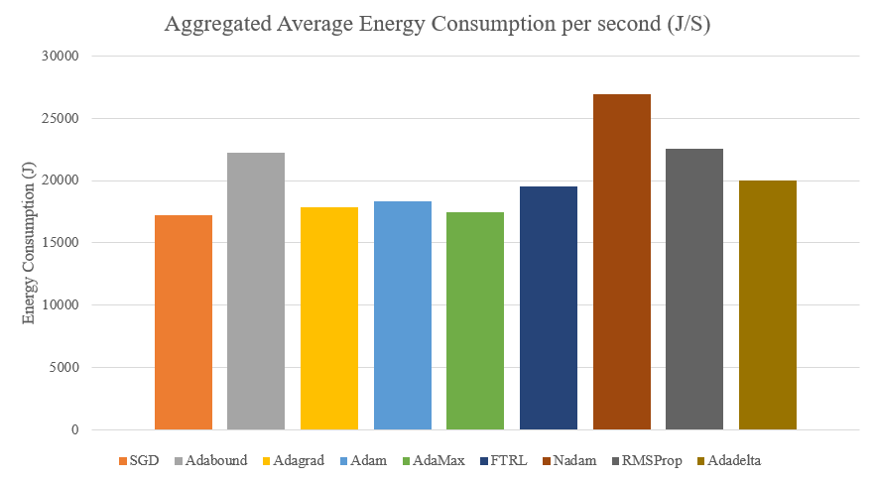

*Figure 4: Aggregated average energy consumption of optimizers*

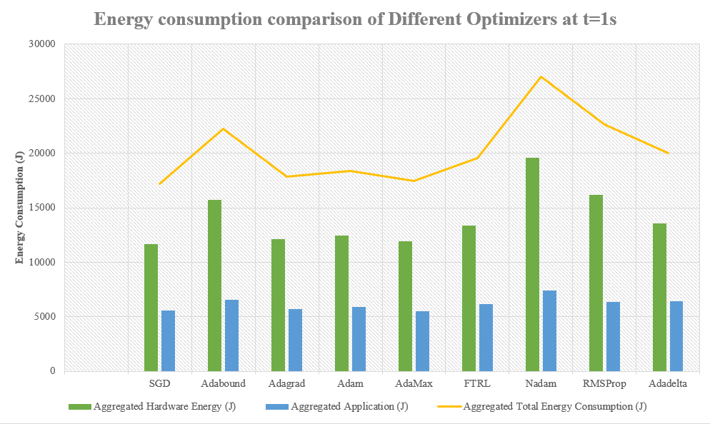

*Figure 5: Comparison of Energy consumption of optimizers*

Figure 4 depicts the aggregated Hardware, application, and total energy consumption of all the optimizers. Figure 5 illustrates the power consumed by each of the hardware.

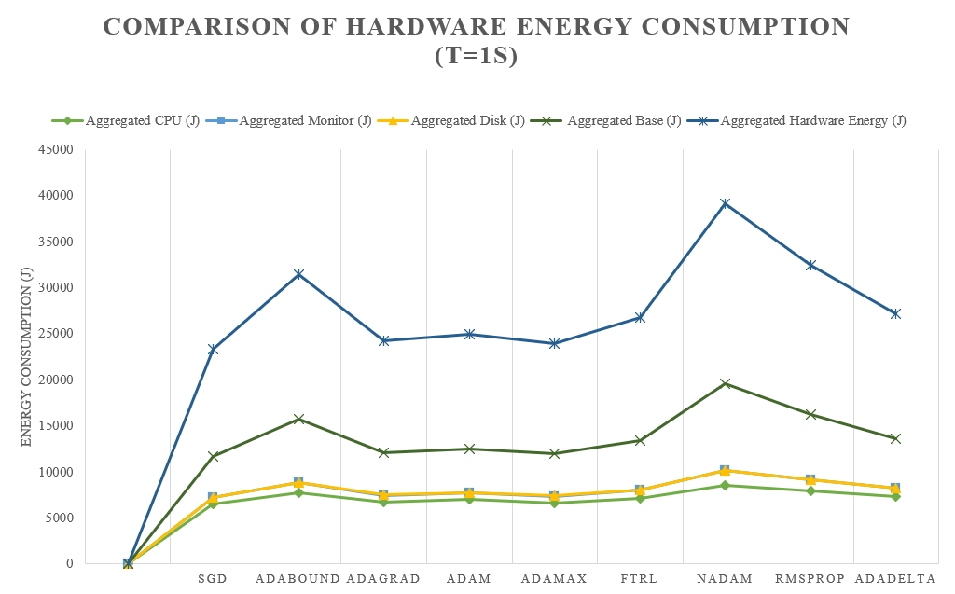

*Figure 6: Hardware Energy consumption comparison of optimizers*

## 4.1 Statistical Analysis

To demonstrate that there is a difference between the Deep learning optimizers in terms of aggregated average energy consumption per second descriptive statistics is shown in the figure 6.

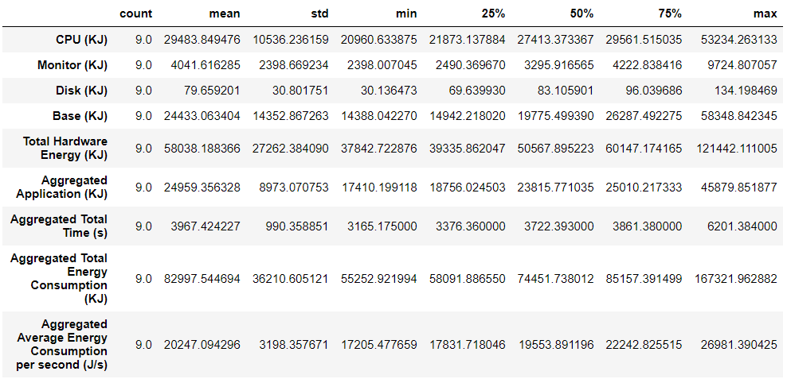

*Figure 7: Descriptive statistics of the optimizer’s energy consumption*

## 4.2 T-Test

With the assumption that the samples are not related, samples are drawn from a normal-distributed population, and the population standard deviations of the groupings are identical (homoscedasticity), to determine if the average energy consumption of these 9 optimizers are statistically distinct or not at the level of significance, a statistical parametric test known as one-way T-test was performed at this stage of the experiment. Here a 95% confidence level (α = 0.05) was chosen to check the hypothesis, which means that if the p value we get in this experiment is greater than the α the null hypothesis will hold true and if otherwise happens the null hypothesis will be rejected.

### SGD and Adabound

T-test between SGD and Adabound was constructed on the following hypotheses:

* Null Hypothesis (H0): The energy consumed by SGD and Adabound on average is same (µ_1=µ_2)
* Alternate Hypothesis (H1): The averages of the optimizers is statistically different (µ_1≠µ_2)

Here, we get a p value of 0.0211 which is fewer than the 95% confidence level (α = 0.05), so we can reject the first hypothesis. As a result, we can deduce that there is a statistical difference in the average power usage of SGD (Stochastic gradient descent) and Adabound.

### SGD and Adagrad

T-test between SGD and Adagrad was constructed on the following hypotheses:

* Null Hypothesis (H0): The energy consumed by SGD and Adagrad on average is same (µ_1=µ_2)
* Alternate Hypothesis (H1): The averages of the optimizers is statistically different (µ_1≠µ_2)

Here, we get a p value of 0.0926 which is greater than the 95% confidence level (α = 0.05), so we cannot reject the null hypothesis. As a result, it can be deduced that there is no statistical difference in the average power usage of SGD (Stochastic gradient descent) and Adagrad.

### SGD and Adam

T-test between SGD and Adam was constructed on the following hypotheses:

* Null Hypothesis (H0): The energy consumed by SGD and Adam on average is same (µ_1=µ_2)
* Alternate Hypothesis (H1): The averages of the optimizers is statistically different (µ_1≠µ_2)

Here, we get a p value of 0.0208 which is fewer than the 95% confidence level (α = 0.05), so we can reject the first hypothesis. As a result, we can deduce that there is a statistical difference in the average power usage of SGD (Stochastic gradient descent) and Adam.

### SGD and AdaMax

T-test between SGD and AdaMax was constructed on the following hypotheses:

* Null Hypothesis (H0): The energy consumed by SGD and AdaMax on average is same (µ_1=µ_2)
* Alternate Hypothesis (H1): The averages of the optimizers is statistically different (µ_1≠µ_2)

Here, we get a p value of 0.0417 which is fewer than the 95% confidence level (α = 0.05), so we can reject the first hypothesis. As a result, we can deduce that there is a statistical difference in the average power usage of SGD (Stochastic gradient descent) and AdaMax.

### SGD and FTRL

T-test between SGD and FTRL was constructed on the following hypotheses:

* Null Hypothesis (H0): The energy consumed by SGD and FTRL on average is same (µ_1=µ_2)
* Alternate Hypothesis (H1): The averages of the optimizers is statistically different (µ_1≠µ_2)

Here, we get a p value of 0.0216 which is fewer than the 95% confidence level (α = 0.05), so we can reject the first hypothesis. As a result, we can deduce that there is a statistical difference in the average power usage of SGD (Stochastic gradient descent) and FTRL.

### SGD and Nadam

T-test between SGD and Nadam was constructed on the following hypotheses:

* Null Hypothesis (H0): The energy consumed by SGD and Nadam on average is same (µ_1=µ_2)
* Alternate Hypothesis (H1): The averages of the optimizers is statistically different (µ_1≠µ_2)

Here, we get a p value of 0.02509 which is fewer than the 95% confidence level (α = 0.05), so we can reject the first hypothesis. As a result, we can deduce that there is a statistical difference in the average power usage of SGD (Stochastic gradient descent) and Nadam.

### SGD and RMSProp

T-test between SGD and RMSProp was constructed on the following hypotheses:

* Null Hypothesis (H0): The energy consumed by SGD and RMSProp on average is same (µ_1=µ_2)
* Alternate Hypothesis (H1): The averages of the optimizers is statistically different (µ_1≠µ_2)

Here, we get a p value of 0.0241 which is fewer than the 95% confidence level (α = 0.05), so we can reject the first hypothesis. As a result, we can deduce that there is a statistical difference in the average power usage of SGD (Stochastic gradient descent) and RMSProp.

### SGD and Adadelta

T-test between SGD and Adadelta was constructed on the following hypotheses:

* Null Hypothesis (H0): The energy consumed by SGD and Adadelta on average is same (µ_1=µ_2)
* Alternate Hypothesis (H1): The averages of the optimizers is statistically different (µ_1≠µ_2)

Here, we get a p value of 0.0202 which is fewer than the 95% confidence level (α = 0.05), so we can reject the first hypothesis. As a result, we can deduce that there is a statistical difference in the average power usage of SGD (Stochastic gradient descent) and Adadelta.

### Adagrad and Adam

T-test between Adagrad and Adam was constructed on the following hypotheses:

* Null Hypothesis (H0): The energy consumed by Adagrad and Adam on average is same (µ_1=µ_2)
* Alternate Hypothesis (H1): The averages of the optimizers is statistically different (µ_1≠µ_2)

Here, we get a p value of 0.0261 which is fewer than the 95% confidence level (α = 0.05), so we can reject the first hypothesis. As a result, we can deduce that there is a statistical difference in the average power usage of Adagrad and Adam.

### AdaMax and FTRL

T-test between AdaMax and FTRL was constructed on the following hypotheses:

* Null Hypothesis (H0): The energy consumed by AdaMax and FTRL on average is same (µ_1=µ_2)
* Alternate Hypothesis (H1): The averages of the optimizers is statistically different (µ_1≠µ_2)

Here, we get a p value of 0.0229 which is fewer than the 95% confidence level (α = 0.05), so we can reject the first hypothesis. As a result, we can deduce that there is a statistical difference in the average power usage of AdaMax and FTRL.

### Nadam and RMSProp

T-test between Nadam and RMSProp was constructed on the following hypotheses:

* Null Hypothesis (H0): The energy consumed by Nadam and RMSProp on average is same (µ_1=µ_2)
* Alternate Hypothesis (H1): The averages of the optimizers is statistically different (µ_1≠µ_2)

Here, we get a p value of 0.0262 which is fewer than the 95% confidence level (α = 0.05), so we can reject the first hypothesis. As a result, we can deduce that there is a statistical difference in the average power usage of Nadam and RMSProp.

### SGD and Adadelta

T-test between SGD and Adadelta was constructed on the following hypotheses:

* Null Hypothesis (H0): The energy consumed by SGD and Adadelta on average is same (µ_1=µ_2)
* Alternate Hypothesis (H1): The averages of the optimizers is statistically different (µ_1≠µ_2)

Here, we get a p value of 0.0262 which is fewer than the 95% confidence level (α = 0.05), so we can reject the first hypothesis. As a result, we can deduce that there is a statistical difference in the average power usage of SGD and Adadelta.

The overall results of all the T-test performed is given in the table

|  |  |  |
| --- | --- | --- |
| Optimizers | P value | T-statistic |
| SGD and Adabound | 0.02110787097 | -2.861340836 |
| SGD and Adagrad | 0.092617741 | 1.90939340 |
| SGD and Adam | 0.02088322 | -2.8683055 |
| SGD and AdaMax | 0.041763378 | 2.4213293 |
| SGD and FTRL | 0.02163235 | -2.8453756 |
| SGD and Nadam | 0.0250927235 | -2.74912772 |
| SGD and RMSProp | 0.024183988 | -2.77301168 |
| SGD and Adadelta | 0.0202536670 | -2.88824348 |
| Adagrad and Adam | 0.02621109081 | -2.720927208 |
| AdaMax and FTRL | 0.02294100122 | -2.807223474 |
| Nadam and RMSProp | 0.02622400949 | 2.7206087308 |
| Adadelta and SGD | 0.02025366707 | -2.888243488 |

*Table 15: T-Test results between the optimizers with α = 0.05*

## 4.3 Carbon Footprint

The quantity of greenhouse gas we create in units of carbon dioxide is referred to as our carbon footprint. This footprint is defined by your everyday activities and lifestyle, such as travel (vehicle, airline, train, etc.), electrical use, product and service use, food intake, and so on. In this step the carbon emission of the deep learning optimizers is calculated through utilizing the GHG conversionss in table 2. Here, as the data collected is in KJ (kilojoule) first it is converted to KWh (kilowatt-hour), then multiplying that value with the conversion factors the carbon emission is calculated. The results obtained from this are indicated in table 16.

|  |  |  |  |  |  |  |
| --- | --- | --- | --- | --- | --- | --- |
| Optimizer | Aggregated Total Energy Consumption (KJ) | Aggregated Total Energy Consumption (KWh) | Carbon emission in CO2e(Kg) | Carbon emission in CO2(Kg) | Carbon emission in CH4(Kg) | Carbon emission in N2O(Kg) |
|
| SGD | 58091.89 | 16.13664 | 3.426292 | 3.391275 | 0.012909 | 0.022107 |
| Adabound | 85157.39 | 23.65483 | 5.02263 | 4.971299 | 0.018924 | 0.032407 |
| Adagrad | 56595.82 | 15.72106 | 3.65586 | 3.61850 | 0.013774 | 0.02358 |
| Adam | 63624.83 | 17.67356 | 3.752628 | 3.714276 | 0.014139 | 0.024213 |
| AdaMax | 55252.92 | 15.34803 | 3.258848 | 3.225543 | 0.012278 | 0.021027 |
| FTRL | 75505 | 20.97361 | 4.453327 | 4.407814 | 0.016779 | 0.028734 |
| Nadam | 167322 | 46.47832 | 9.868742 | 9.767884 | 0.037183 | 0.063675 |
| RMSProp | 110976.3 | 30.82676 | 6.545446 | 6.478552 | 0.024661 | 0.042233 |
| Adadelta | 74451.74 | 20.68104 | 4.391205 | 4.346327 | 0.016545 | 0.028333 |

*Table 16: Carbon footprint of deep learning optimizers*

From table 16 we can discern that the Nadam optimizer contributed 9.86 kg of CO2e emission, which is the highest among the optimizers. Here, AdaMax optimizer released the least amount of carbon, for CO2e its contribution is 3.25kg, for CO2 it's 3.22kg, for CH4 0.012 kg, and for N2O it's just 0.021kg. But in the previous figures we have seen that the SGD optimizer is the one which is the most efficient. The reason behind the discrepancy is that there was an error in one of the runs of AdaMax optimizer. If we compensate for the error, we will get an aggregated total energy consumption of 61392.13 KJ for AdaMax optimizer. The same error case was also true for the Adabound optimizer. After the changes the table above would look like table 17.

|  |  |  |  |  |  |  |
| --- | --- | --- | --- | --- | --- | --- |
| Optimizer | Aggregated Total Energy Consumption (KJ) | Aggregated Total Energy Consumption (KWh) | Carbon emission in CO2e(Kg) | Carbon emission in CO2(Kg) | Carbon emission in CH4(Kg) | Carbon emission in N2O(Kg) |
|
| SGD | 58091.89 | 16.13664 | 3.426292 | 3.391275 | 0.012909 | 0.022107 |
| Adabound | 106446.73 | 29.5685361 | 6.27828 | 6.21412 | 0.023654 | 0.04050 |
| Adagrad | 61984.21 | 17.21784 | 3.655863 | 3.618501 | 0.013774 | 0.023588 |
| Adam | 63624.83 | 17.67356 | 3.752628 | 3.714276 | 0.014139 | 0.024213 |
| AdaMax | 61392.13 | 17.05337 | 3.620942 | 3.583936 | 0.013643 | 0.023363 |
| FTRL | 75505 | 20.97361 | 4.453327 | 4.407814 | 0.016779 | 0.028734 |
| Nadam | 167322 | 46.47832 | 9.868742 | 9.767884 | 0.037183 | 0.063675 |
| RMSProp | 110976.3 | 30.82676 | 6.545446 | 6.478552 | 0.024661 | 0.042233 |
| Adadelta | 74451.74 | 20.68104 | 4.391205 | 4.346327 | 0.016545 | 0.028333 |

*Table 17: Revised carbon footprint of the optimizers*

From the table above we can discern that SGD has the least amount of carbon footprint to the environment. Finally, the results are illustrated in the following figure:

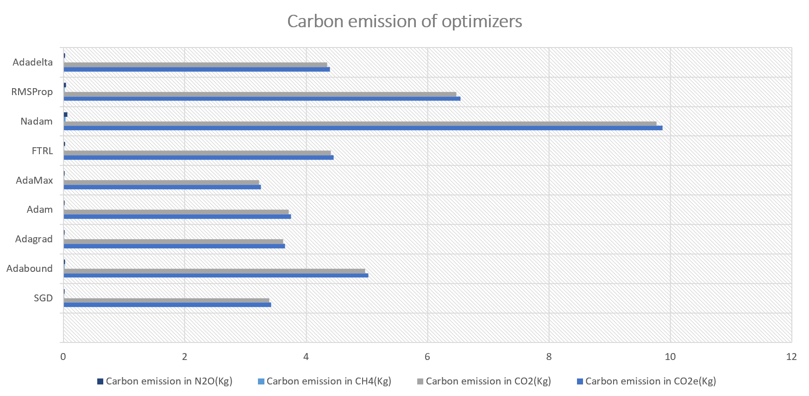

*Figure 7: Different carbon emissions of the optimizers*

## 4.4 Validation challenges

Purpose of this research is to quantify as well as comprehend the power usage patterns of nine deep learning optimizers. This research will reveal how one optimizer performs in terms of energy usage when compared to other deep learning optimizers. Internal validity, external validity, validity of conclusion, and validity of construct are four kinds of probable validity issues in this study (Wohlin et al., 2012). (i) Validity of conclusion denotes elements that may have an impact on the credibility of findings made. It is obvious from the results of this study's trials that different optimizers consume variable amounts of processing-related energy. The power usage of the processor, or other sources usage have been analysed for a proper comparison. (ii) Validity of construct deals with applying the findings to the concepts or hypotheses that underpin the experiments. These nine deep learning optimizers has been employed in disparate languages (programming) in reality. However, in this study, every model was developed in Python in the Jupyter notebook, then power usage of these algorithms was evaluated in Joulemeter. It allows the comparison of energy usage among several optimizers when doing the same activity. Initiatives have been introduced to verify that the experimental methods for all nine optimizers are comparable. (iii) internal validity is concerned with the elements that may skew the findings of a research. Other factors, such as various executions of models with various languages, might lead to variances, while testing the energy consumption of the nine optimizers. To avoid this, every deep learning optimizer has been developed in Jupyter notebook and the energy consumption of these optimizers has been collected via Joulemeter software. Furthermore, each optimizer was run ten times on a specific laptop. This allowed us to reduce the specific conditions of the machine under test, such as uncontrolled system activities and software. (iv) External validity is about the generalisation of the findings. The greenest optimizer discovered in this work is the result of multiple sets of trials. We couldn't draw a generalisation about the greenest optimizer since it required further tests with all other optimizers because there are many other optimizers and their variants in. Experiments carried out on various devices would also provide varied findings. The deep learning optimizers would have to be implemented on the same system to ensure uniformity and legitimate results. As a result, the experiment protocols must be reported in order to comprehend their application in various circumstances.

# Conclusion and Future Work

In this research 9 optimizers used in deep learning models are assessed in terms of power usage and carbon footprint. SGD has proven to be the most efficient while considering energy efficiency and GHG emissions. The analysis also shows that Adagrad and AdaMax optimizers performed very close to Stochastic Gradient descent, which means these optimizers are also efficient. To determine if the difference is significant or not in the next step of the experiment T-test was performed among the results of the optimizers, which reveals that except Adagrad other optimizers results are significantly different. This study corroborates that the use of different optimizers in deep learning models have significant effects on the power usage and emissions. Moreover, the purpose of this research is to create more apprehension of the power usage efficiency issue with deep learning optimizers and to encourage researchers to do further research in this area in order to give practical but environmentally friendly solutions and not widen the focus from just the performance of the deep learning models and optimizers.

However, there are other hyperparameters in CNN models which also play a critical part in the CNN models' performances. So further studies can be conducted on how much those effects actually contribute to the performance and efficiency of deep learning models. We also did not consider all the deep learning optimizers in this study which can be experimented in future to find the best or top five most efficient and green deep learning optimizers. Moreover, other systems with different configurations can also be considered to study the effects of these deep learning optimizers on power consumption and environmental impact. Furthermore, as the machine and deep learning models are getting utilized in other web and mobile platforms the effects of these deep learning optimizers can also be studied there.

# References

* Aqib, M. & Fouz, F. F., 2016. The effect of parallel programming languages on the performance and energy consumption of HPC applications. International Journal of Advanced Computer Science and Applications, 7(2)
* BCS, The Chartered Institute for IT. (2012). Green IT: Managing your Carbon Footprint, Publisher: British Informatics Society Ltd.
* Bellosa, F., Weissel, A., Waitz, M. and Kellner, S., 2003, September. Event-driven energy accounting for dynamic thermal management. In Proceedings of the Workshop on Compilers and Operating Systems for Low Power (COLP’03) (Vol. 22).
* Bertran, R., Gonzalez, M., Martorell, X., Navarro, N. and Ayguade, E., 2010, June. Decomposable and responsive power models for multicore processors using performance counters. In Proceedings of the 24th ACM International Conference on Supercomputing (pp. 147-158).
* Brooks, D., Tiwari, V. and Martonosi, M., 2000. Wattch: A framework for architectural-level power analysis and optimizations. ACM SIGARCH Computer Architecture News, 28(2), pp.83-94.
* Bera, S. and Shrivastava, V.K., 2020. Analysis of various optimizers on deep convolutional neural network model in the application of hyperspectral remote sensing image classification. International Journal of Remote Sensing, 41(7), pp.2664-2683.
* Choi, D., Shallue, C.J., Nado, Z., Lee, J., Maddison, C.J. and Dahl, G.E., 2019. On empirical comparisons of optimizers for deep learning. arXiv preprint arXiv:1910.05446.
* Chavan, T.R. and Nandedkar, A.V., 2018. AgroAVNET for crops and weeds classification: A step forward in automatic farming. Computers and Electronics in Agriculture, 154, pp.361-372.
* Dolci, D.B., Lunardi, G.L., Salles, A.C. and Alves, A.P.F., 2015. Implementation of green IT in organizations: A structurational view. Revista de Administração de Empresas, 55, pp.486-497.
* Dozat, T., 2016. Incorporating nesterov momentum into adam.
* Economou, D., Rivoire, S., Kozyrakis, C. and Ranganathan, P., 2006. Full-system power analysis and modeling for server environments. International Symposium on Computer Architecture (IEEE).
* Fettweis, G. & Zimmermann, E., 2008. ICT energy consumption-trends and challenges. Lapland, 11th international symposium on wireless personal multimedia communications.
* García-Martín, E., Rodrigues, C.F., Riley, G. and Grahn, H., 2019. Estimation of energy consumption in machine learning. Journal of Parallel and Distributed Computing, 134, pp.75-88.
* Gilberto, C. and Margaret, M., 2005. Power prediction for intel xscale processors using performance monitoring unit events power prediction for intel xscale processors using performance monitoring unit events. In ISLPED (Vol. 5, pp. 8-10).
* Goel, B. and McKee, S.A., 2016, May. A methodology for modeling dynamic and static power consumption for multicore processors. In 2016 IEEE International Parallel and Distributed Processing Symposium (IPDPS) (pp. 273-282). IEEE.
* Hosangadi, A., Kastner, R. and Fallah, F., 2005, January. Energy efficient hardware synthesis of polynomial expressions. In 18th International Conference on VLSI Design held jointly with 4th International Conference on Embedded Systems Design (pp. 653-658). IEEE.
* Houghton, J. (n.d.). ICT and the environment: A framework for analysis, Melbourne: Victoria University, Available at: https://www.oecd.org/sti/ieconomy/40833025.pdf, (Accessed: 04/12/2022).
* Howard, A.G., Zhu, M., Chen, B., Kalenichenko, D., Wang, W., Weyand, T., Andreetto, M. and Adam, H., 2017. Mobilenets: Efficient convolutional neural networks for mobile vision applications. arXiv preprint arXiv:1704.04861.
* He, K., Zhang, X., Ren, S. and Sun, J., 2016. Deep residual learning for image recognition. In Proceedings of the IEEE conference on computer vision and pattern recognition (pp. 770-778).
* Huang, G., Liu, Z., Van Der Maaten, L. and Weinberger, K.Q., 2017. Densely connected convolutional networks. In Proceedings of the IEEE conference on computer vision and pattern recognition (pp. 4700-4708).
* Jörg, T., 2013. Efficiency starts with the power supply. Journal of network solutions/LAN, Volume 4.
* Joseph, R. and Martonosi, M., 2001, August. Run-time power estimation in high performance microprocessors. In Proceedings of the 2001 international symposium on Low power electronics and design (pp. 135-140).
* Khan, R.U., Khan, S.U., Khan, R.A. and Ali, S., 2015. Motivators in green IT-outsourcing from vendor’s perspective: A systematic literature review. Proceedings of the Pakistan Academy of Sciences, 52(4), pp.345-360.
* Krizhevsky, A., Sutskever, I. and Hinton, G.E., 2012. Imagenet classification with deep convolutional neural networks. Advances in neural information processing systems, 25.
* Kansal, A. and Zhao, F., 2008. Fine-grained energy profiling for power-aware application design. ACM SIGMETRICS Performance Evaluation Review, 36(2), pp.26-31.
* Kansal, A., Goraczko, M., Liu, J. and Zhao, F., 2010. Joulemeter: Computational Energy Measurement and Optimization. Microsoft Research, Redmond, United States [Consultado a 1 Julho 2014]. Disponível em URL: http://research. microsoft. com/en-us/projects/joulemeter.
* Kothari, N. & Bhattacharya, A., 2009. Joulemeter: Virtual machine power measurement and management, s.l.: MSR Tech Report
* LeCun, Y., Bengio, Y. and Hinton, G., 2015. Deep learning. nature, 521(7553), pp.436-444.
* Liu, B., Zhang, Y., He, D. and Li, Y., 2017. Identification of apple leaf diseases based on deep convolutional neural networks. Symmetry, 10(1), p.11.
* Lee, B.C. and Brooks, D.M., 2006. Accurate and efficient regression modeling for microarchitectural performance and power prediction. ACM SIGOPS operating systems review, 40(5), pp.185-194.
* Li, S., Ahn, J.H., Strong, R.D., Brockman, J.B., Tullsen, D.M. and Jouppi, N.P., 2009, December. McPAT: An integrated power, area, and timing modeling framework for multicore and manycore architectures. In Proceedings of the 42nd annual ieee/acm international symposium on microarchitecture (pp. 469-480).
* Laurenzano, M.A., Tiwari, A., Jundt, A., Peraza, J., Ward, W.A., Campbell, R. and Carrington, L., 2014, August. Characterizing the performance-energy tradeoff of small ARM cores in HPC computation. In European Conference on Parallel Processing (pp. 124-137). Springer, Cham.
* Mark Labbe, 26 Aug 2021. Energy consumption of AI poses environmental problems. Available at: <https://www.techtarget.com/searchenterpriseai/feature/Energy-consumption-of-AI-poses-environmental-problems#:~:text=AI%20energy%20consumption%20during%20training&text=A%20single%20V100%20GPU%20can,27%2C648%20kilowatt%20hours%20(kWh)>. (Accessed: 9th April 2022).
* Magazzino, C., Porrini, D., Fusco, G. & Schneider, N., 2021. Investigating the link among ICT, electricity consumption, air pollution, and economic growth in EU countries. Energy Sources, Part B: Economics, Planning, and Policy, pp. 1-23
* Mazouz, A., Wong, D.C., Kuck, D. and Jalby, W., 2017, April. An incremental methodology for energy measurement and modeling. In Proceedings of the 8th ACM/SPEC on International Conference on Performance Engineering (pp. 15-26).
* McMahan, H.B., Holt, G., Sculley, D., Young, M., Ebner, D., Grady, J., Nie, L., Phillips, T., Davydov, E., Golovin, D. and Chikkerur, S., 2013, August. Ad click prediction: a view from the trenches. In Proceedings of the 19th ACM SIGKDD international conference on Knowledge discovery and data mining (pp. 1222-1230).
* Okewu, E., Adewole, P. and Sennaike, O., 2019, July. Experimental comparison of stochastic optimizers in deep learning. In *International Conference on Computational Science and Its Applications* (pp. 704-715). Springer, Cham.
* Postalcıoğlu, S., 2020. Performance analysis of different optimizers for deep learning-based image recognition. *International Journal of Pattern Recognition and Artificial Intelligence*, *34*(02), p.2051003.
* Perin, G. and Picek, S., 2020, October. On the influence of optimizers in deep learning-based side-channel analysis. In International Conference on Selected Areas in Cryptography (pp. 615-636). Springer, Cham.
* Rethinagiri, S.K., Palomar, O., Ben Atitallah, R., Niar, S., Unsal, O. and Kestelman, A.C., 2014, January. System-level power estimation tool for embedded processor based platforms. In Proceedings of the 6th Workshop on Rapid Simulation and Performance Evaluation: Methods and Tools (pp. 1-8).
* Strubell, E., Ganesh, A. and McCallum, A., 2019. Energy and policy considerations for deep learning in NLP. arXiv preprint arXiv:1906.02243.
* Simunic, T., Benini, L. and De Micheli, G., 2001. Energy-efficient design of battery-powered embedded systems. IEEE Transactions on Very Large Scale Integration (VLSI) Systems, 9(1), pp.15-28.
* Schmitz, M.T., Al-Hashimi, B.M. and Eles, P., 2004. System-level design techniques for energy-efficient embedded systems. Springer Science & Business Media.
* Shiri, A., Mazumder, A.N., Prakash, B., Manjunath, N.K., Homayoun, H., Sasan, A., Waytowich, N.R. and Mohsenin, T., 2020, September. Energy-efficient hardware for language guided reinforcement learning. In Proceedings of the 2020 on Great Lakes Symposium on VLSI (pp. 131-136).
* Szegedy, C., Liu, W., Jia, Y., Sermanet, P., Reed, S., Anguelov, D., Erhan, D., Vanhoucke, V. and Rabinovich, A., 2015. Going deeper with convolutions. In Proceedings of the IEEE conference on computer vision and pattern recognition (pp. 1-9).
* Sermanet, P., Eigen, D., Zhang, X., Mathieu, M., Fergus, R. and LeCun, Y., 2013. Overfeat: Integrated recognition, localization and detection using convolutional networks. arXiv preprint arXiv:1312.6229.
* Szegedy, C., Ioffe, S., Vanhoucke, V. and Alemi, A.A., 2017, February. Inception-v4, inception-resnet and the impact of residual connections on learning. In Thirty-first AAAI conference on artificial intelligence.
* Simonyan, K. and Zisserman, A., 2014. Very deep convolutional networks for large-scale image recognition. arXiv preprint arXiv:1409.1556.
* Schmidt, R.M., Schneider, F. and Hennig, P., 2021, July. Descending through a crowded valley-benchmarking deep learning optimizers. In International Conference on Machine Learning (pp. 9367-9376). PMLR.
* Saleem, M.H., Potgieter, J. and Arif, K.M., 2020. Plant disease classification: A comparative evaluation of convolutional neural networks and deep learning optimizers. *Plants*, *9*(10), p.1319.
* Shallue, C.J., Lee, J., Antognini, J., Sohl-Dickstein, J., Frostig, R. and Dahl, G.E., 2018. Measuring the effects of data parallelism on neural network training. *arXiv preprint arXiv:1811.03600*.
* Sami, M., Sciuto, D., Silvano, C. and Zaccaria, V., 2002. An instruction-level energy model for embedded VLIW architectures. IEEE Transactions on Computer-Aided Design of Integrated Circuits and Systems, 21(9), pp.998-1010.
* Vijayaraghavan, A. & Dornfeld, D., 2010. Automated energy monitoring of machine tools. CIRP annals, 59(1), pp. 21-24.
* Wilson, A.C., Roelofs, R., Stern, M., Srebro, N. and Recht, B., 2017. The marginal value of adaptive gradient methods in machine learning. *Advances in neural information processing systems*, *30*.
* Webb M, et al. Smart 2020: Enabling the low carbon economy in the information age. Clim Group Lond. 2008;1(1):1
* Will de Freitas, 14 Dec 2020. It takes a lot of energy for machines to learn – here’s why AI is so power-hungry. Available at: https://theconversation.com/it-takes-a-lot-of-energy-for-machines-to-learn-heres-why-ai-is-so-power-hungry-151825 (Accessed: 12th April 2022).
* Wohlin, C., Runeson, P., Höst, M., Ohlsson, M.C., Regnell, B. and Wesslén, A., 2012. *Experimentation in software engineering*. Springer Science & Business Media.
* Yi, M. Konsor, P (2014) Intel Power Gadget. Available at: software.intel.com (Accessed 13th April 2022)
* Yong, Z., & Ming Z., 2020, Research on deep learning in apple leaf disease recognition. In Computers and Electronics in Agriculture, Volume 168, ISSN 0168-1699.
* Zeiler, M.D. and Fergus, R., 2014, September. Visualizing and understanding convolutional networks. In European conference on computer vision (pp. 818-833). Springer, Cham.
* Zhang, X., Qiao, Y., Meng, F., Fan, C. and Zhang, M., 2018. Identification of maize leaf diseases using improved deep convolutional neural networks. Ieee Access, 6, pp.30370-30377.
* Zeiler, M.D., 2012. Adadelta: an adaptive learning rate method. arXiv preprint arXiv:1212.5701.

# Appendix

#### Code of Adabound optimizer:

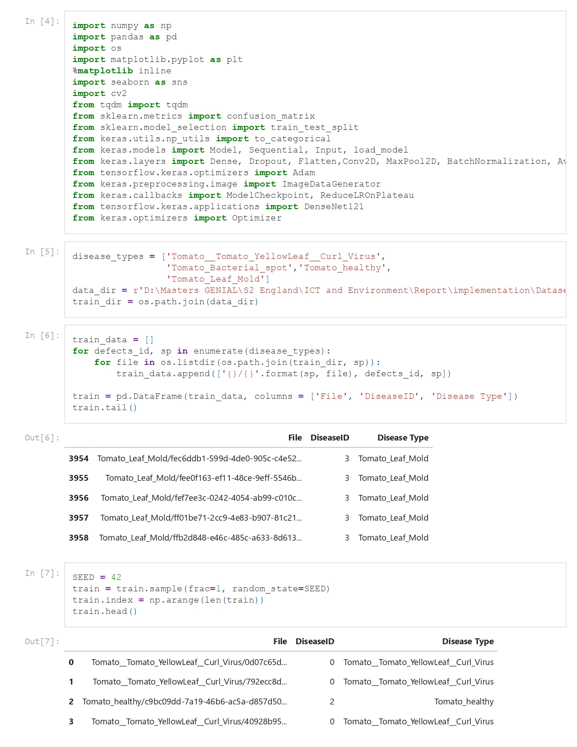

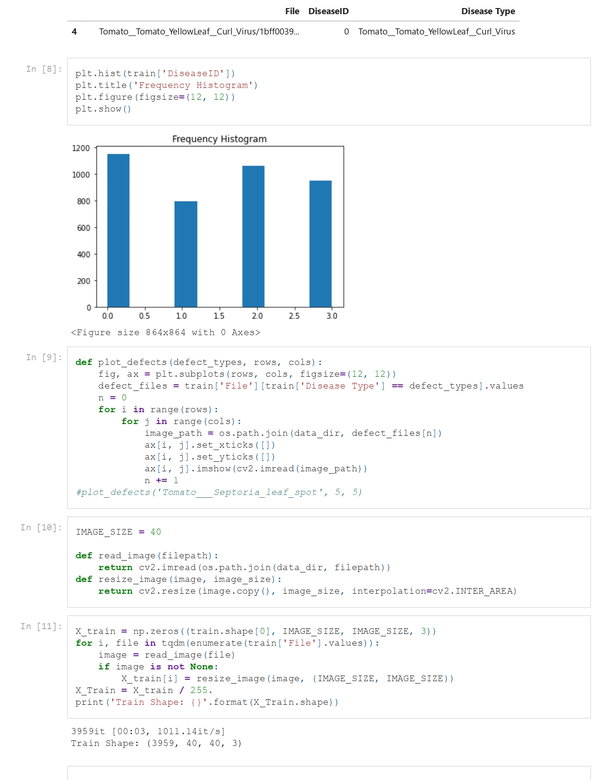

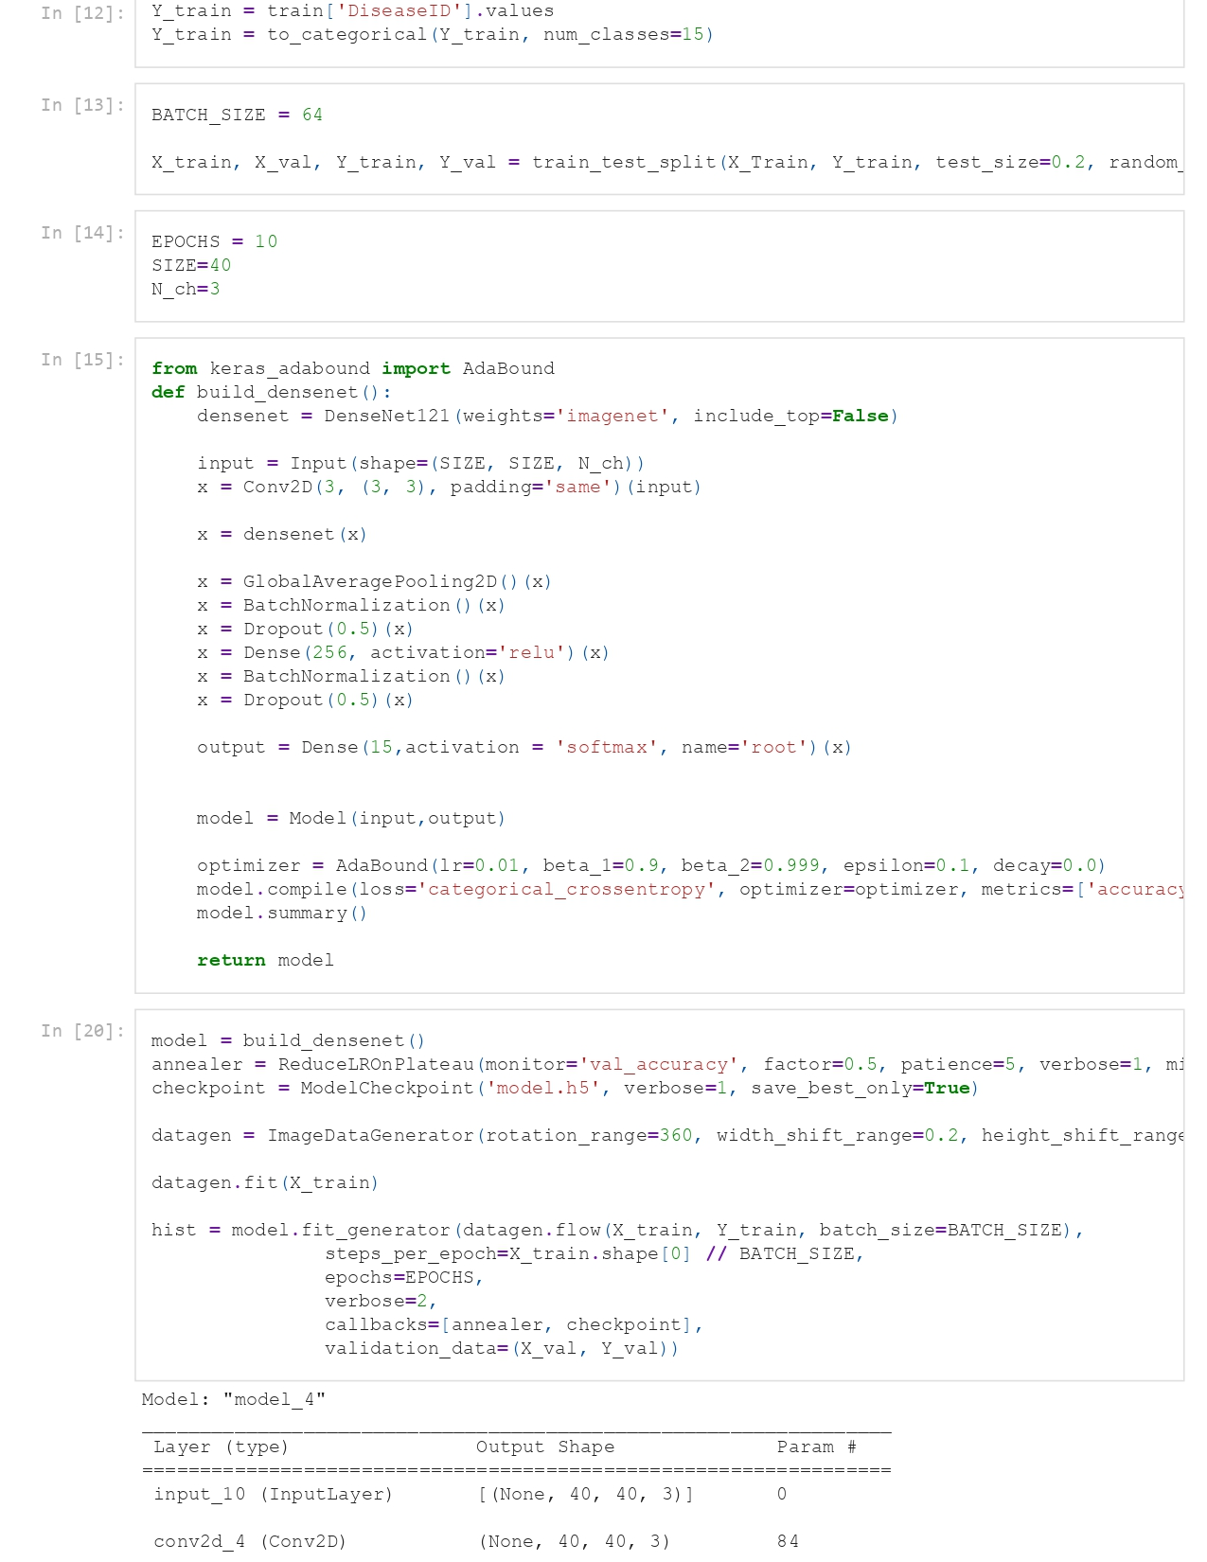

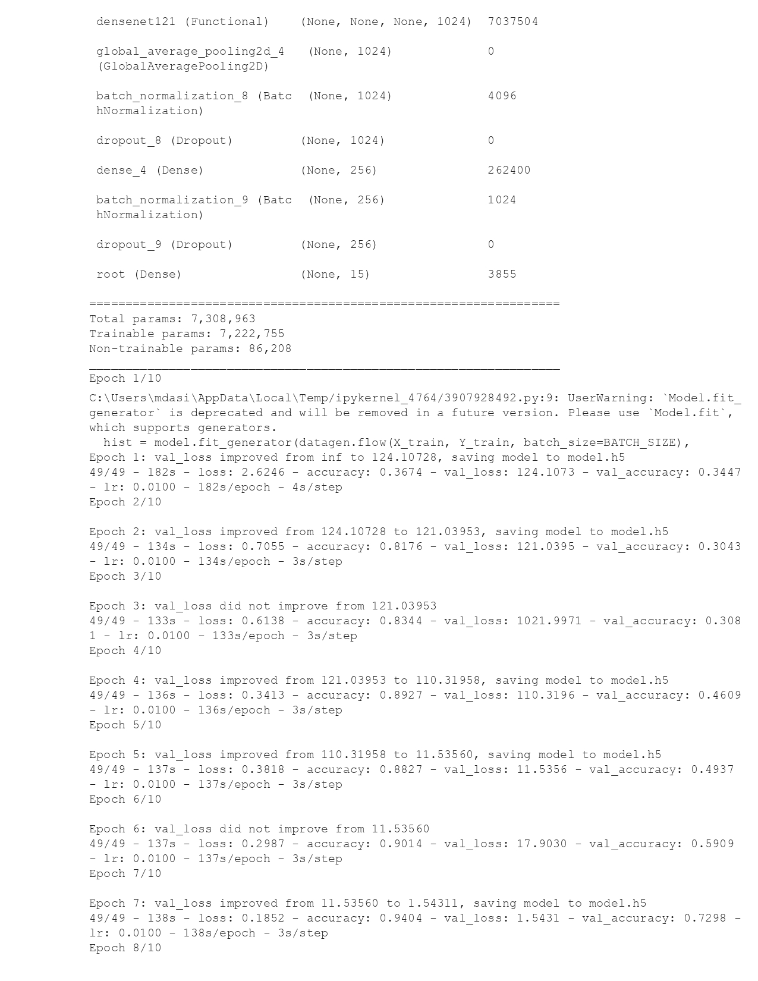

#### Code of Adadelta Optimizer:

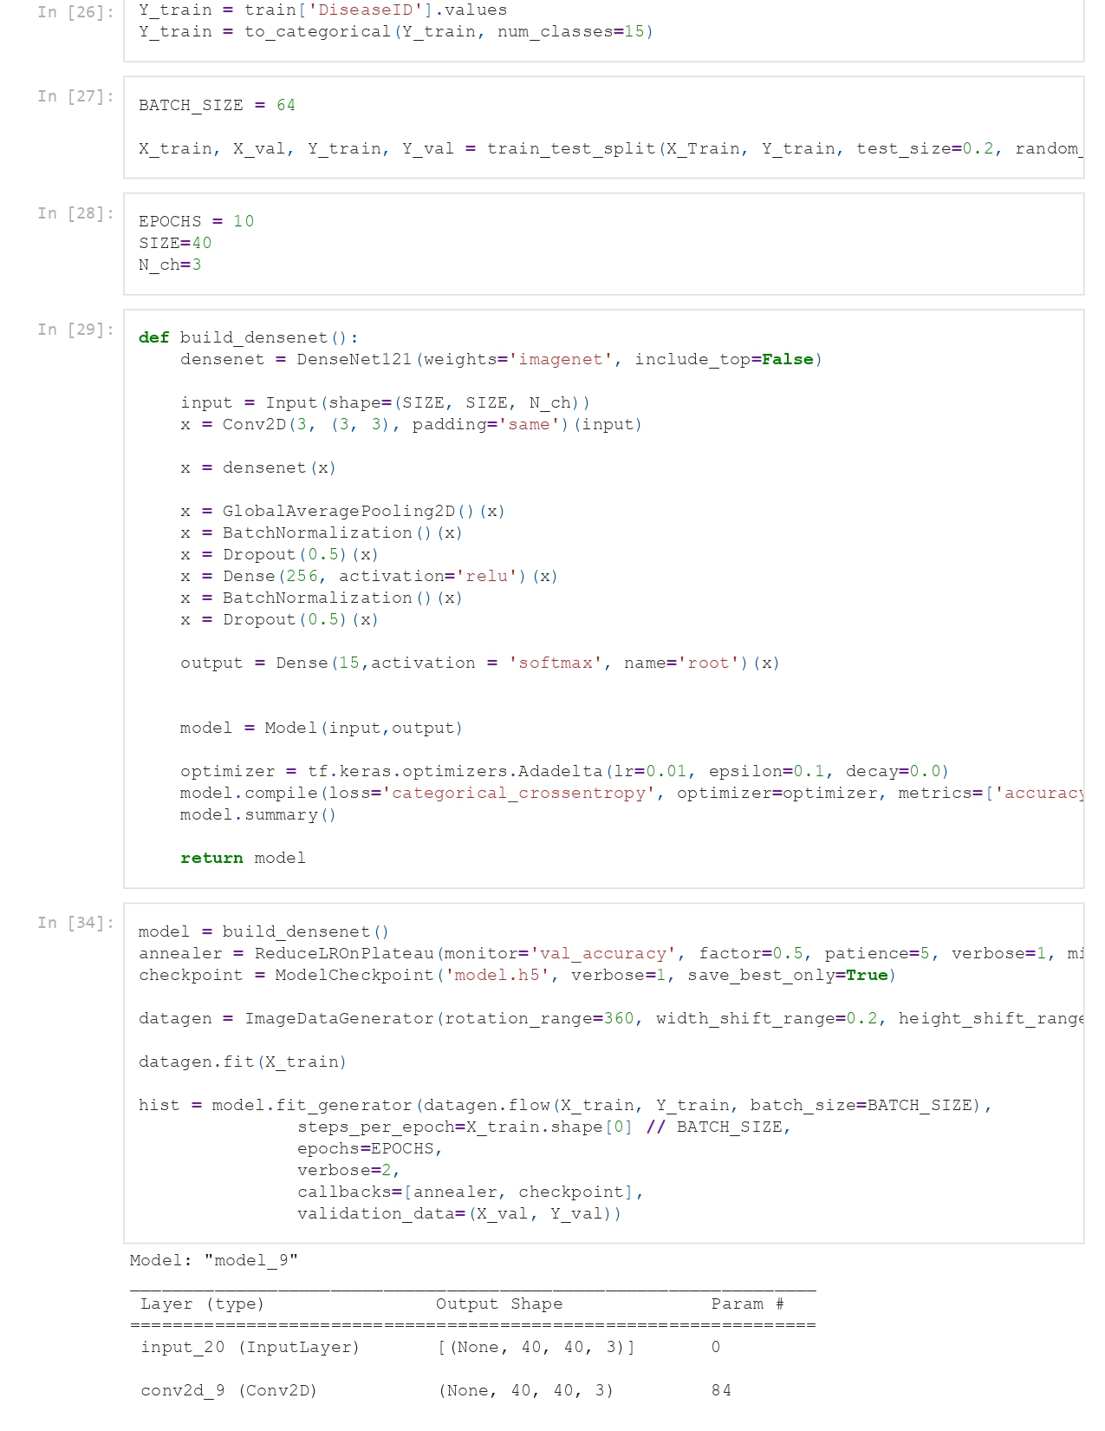

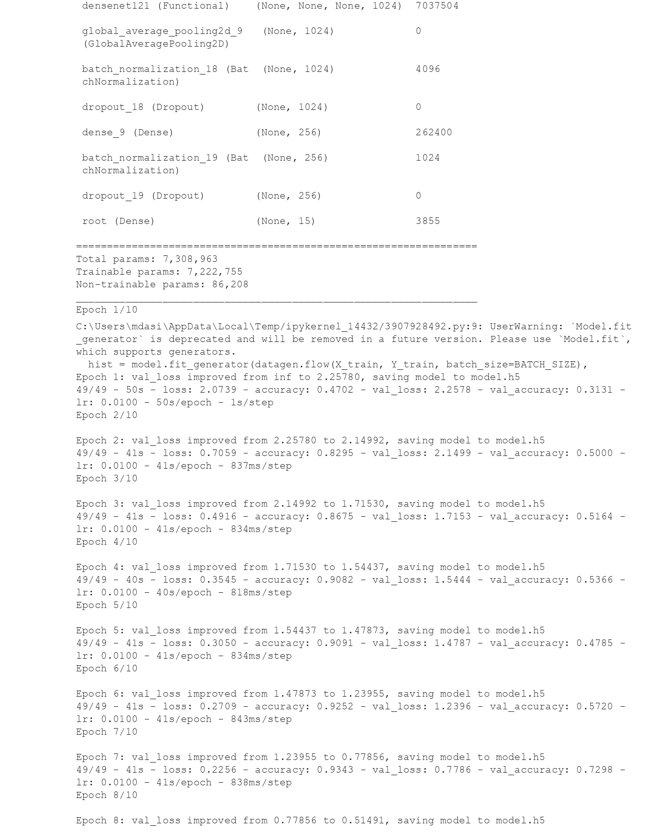

#### Code of Adagrad optimizer

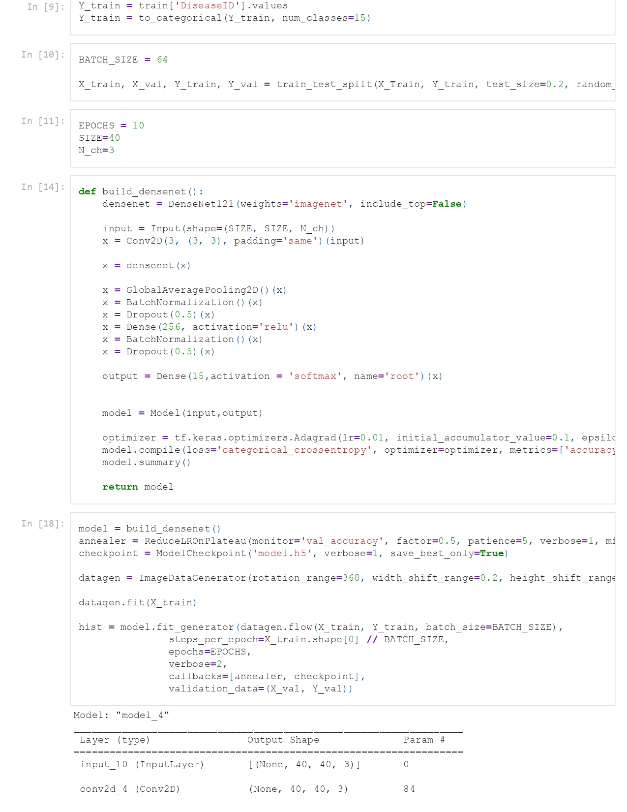

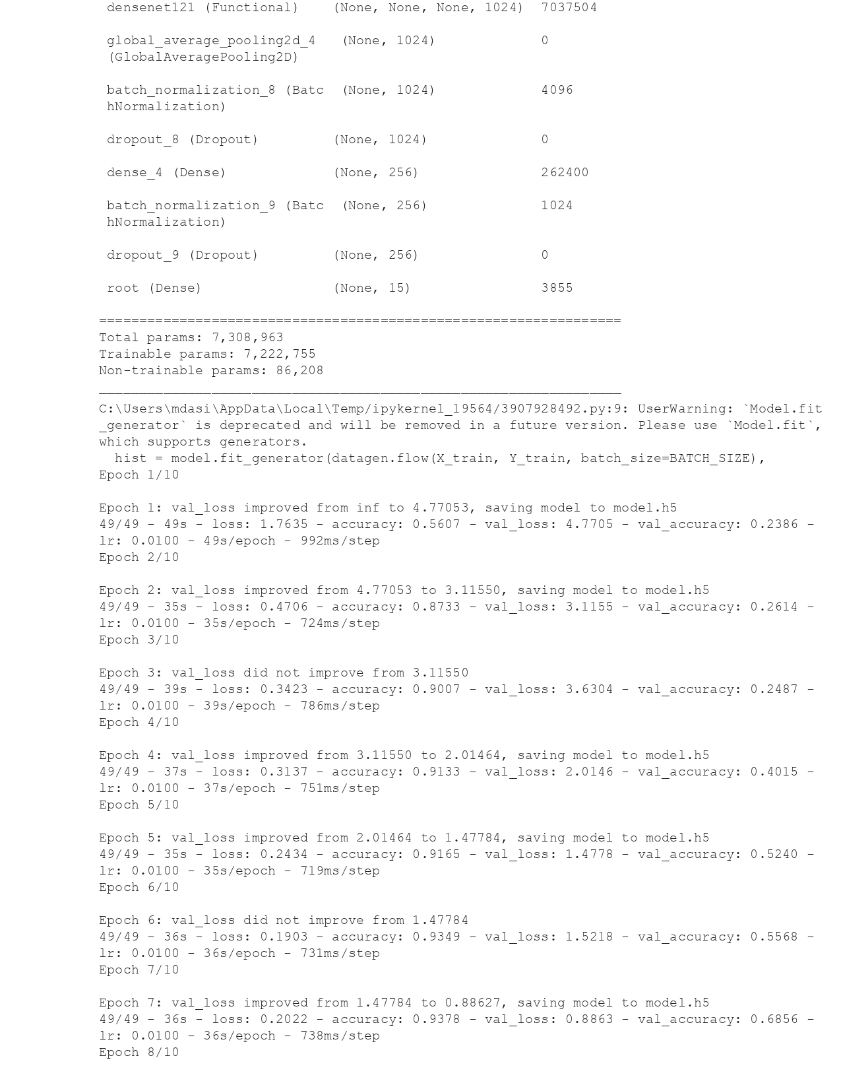

#### Code of AdaMax optimizer

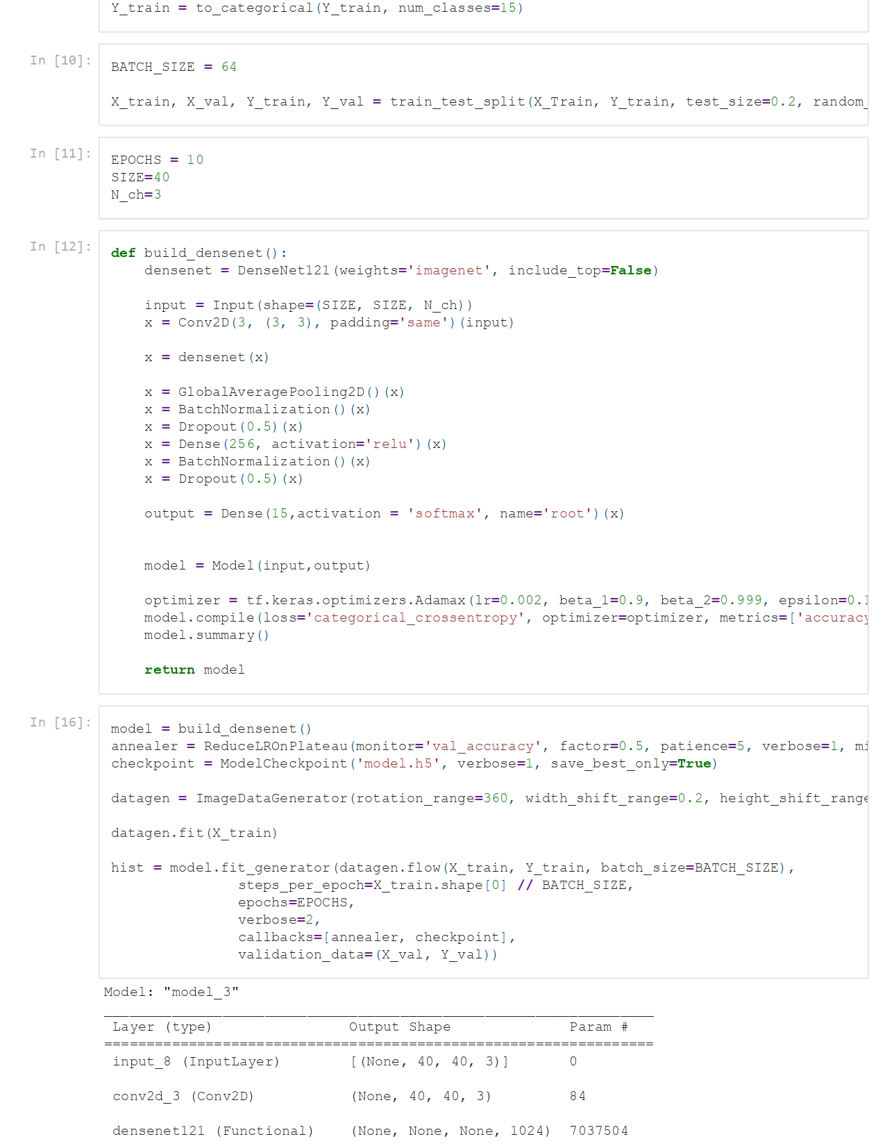

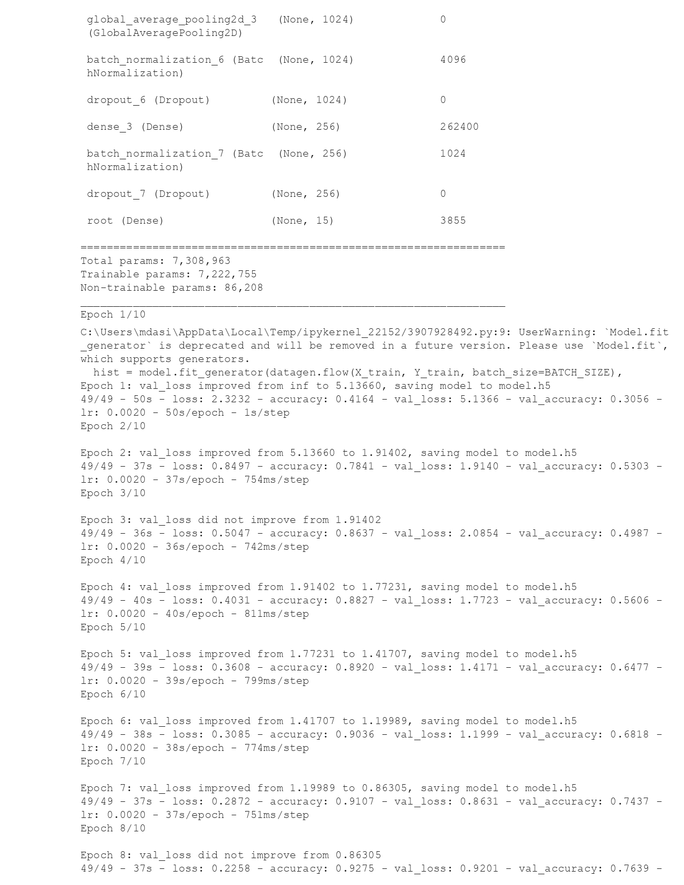

#### Code of Adam Optimizer

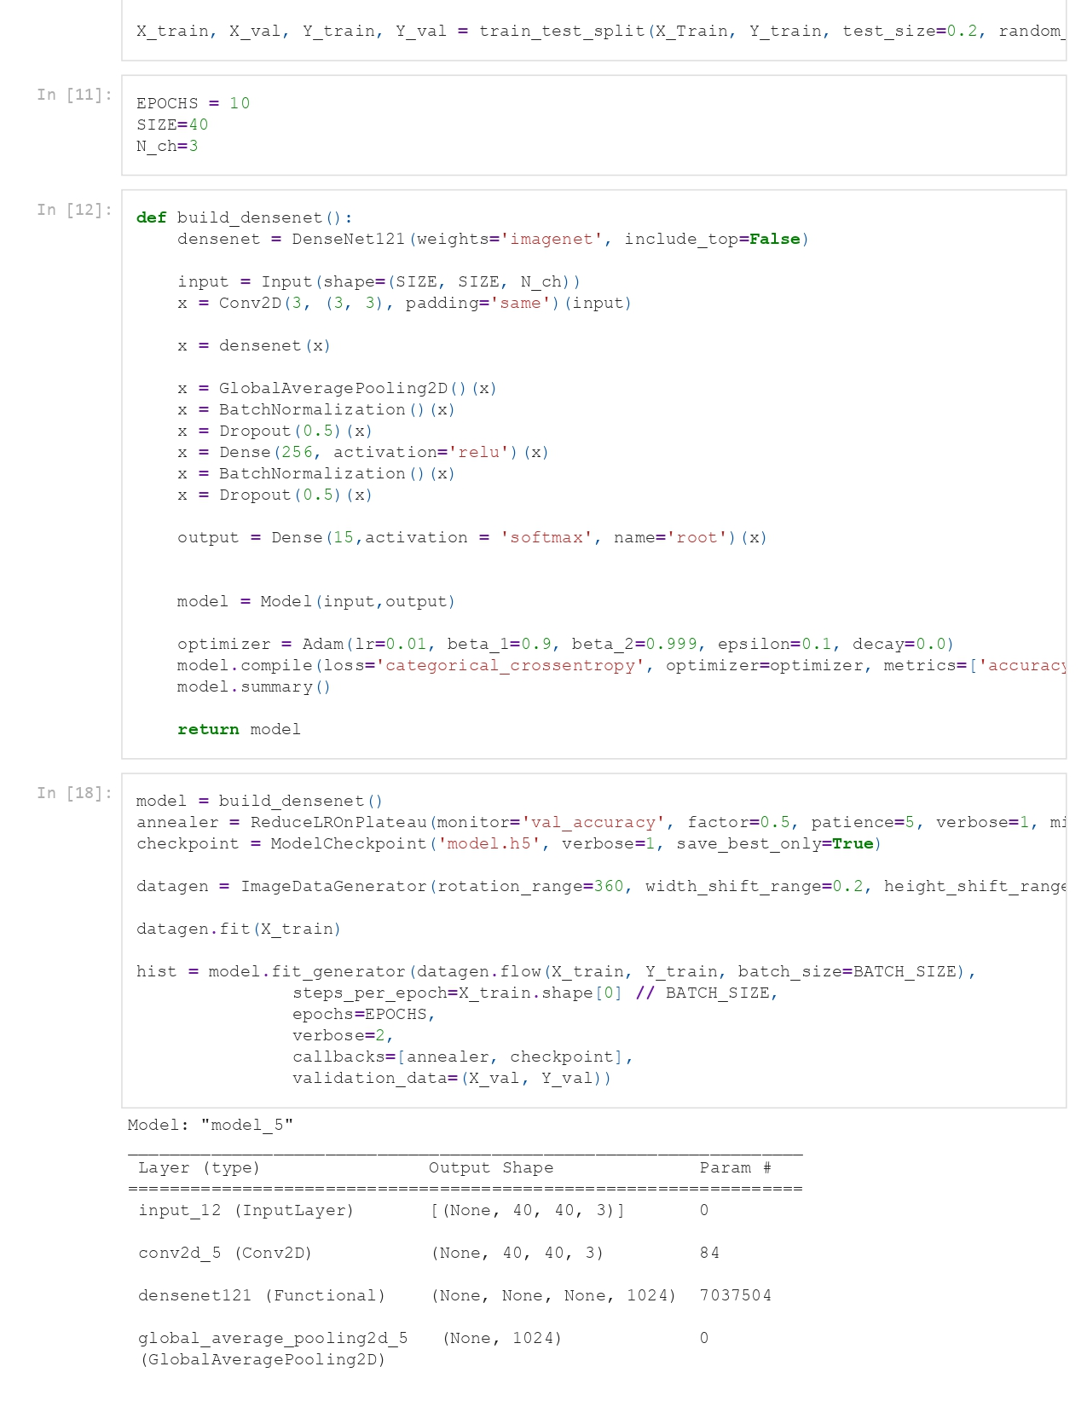

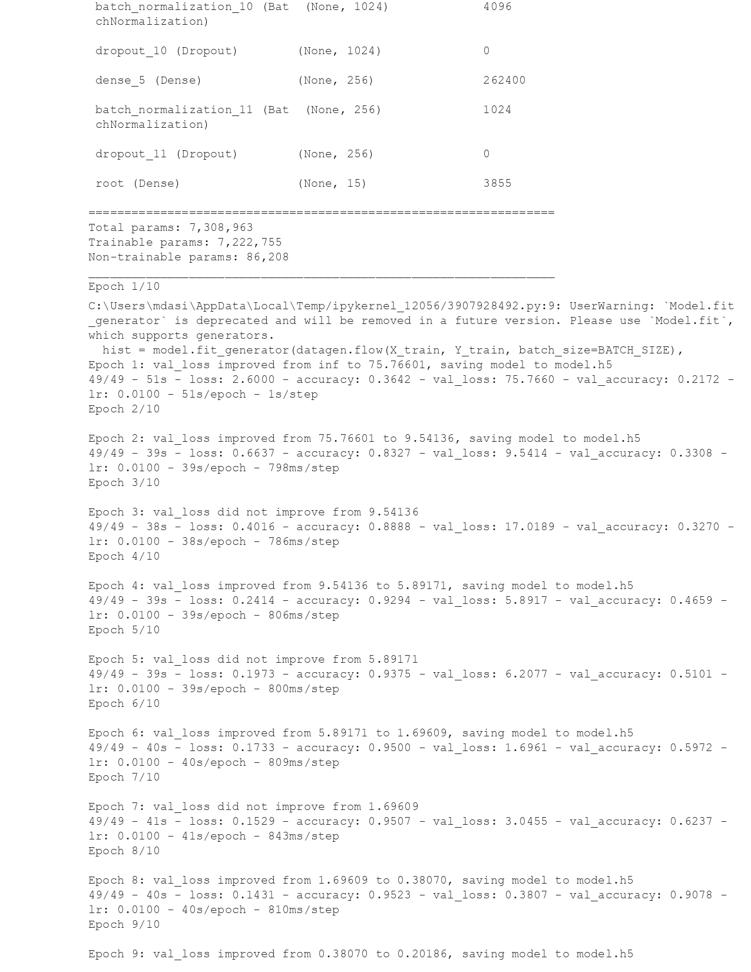

#### Code of FTRL optimizer

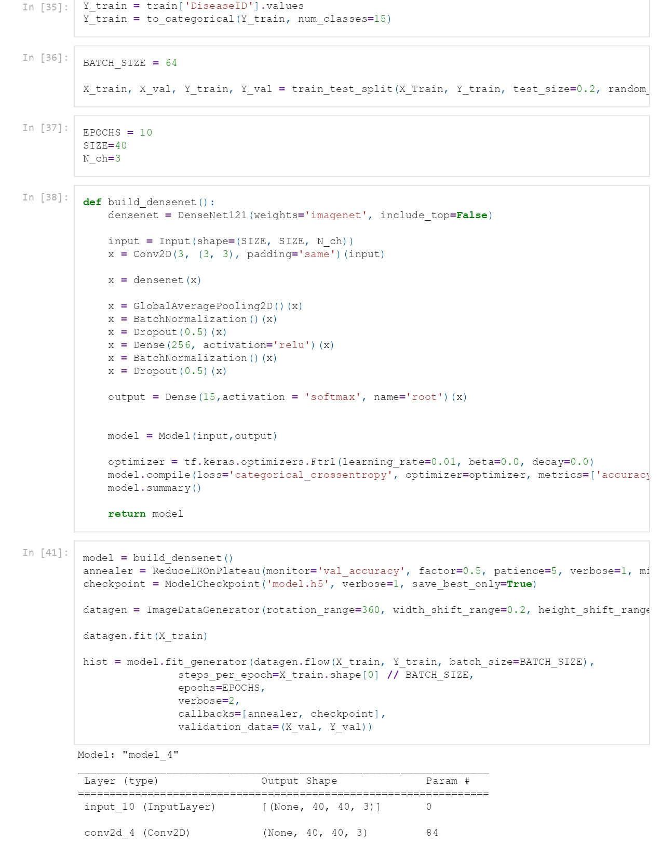

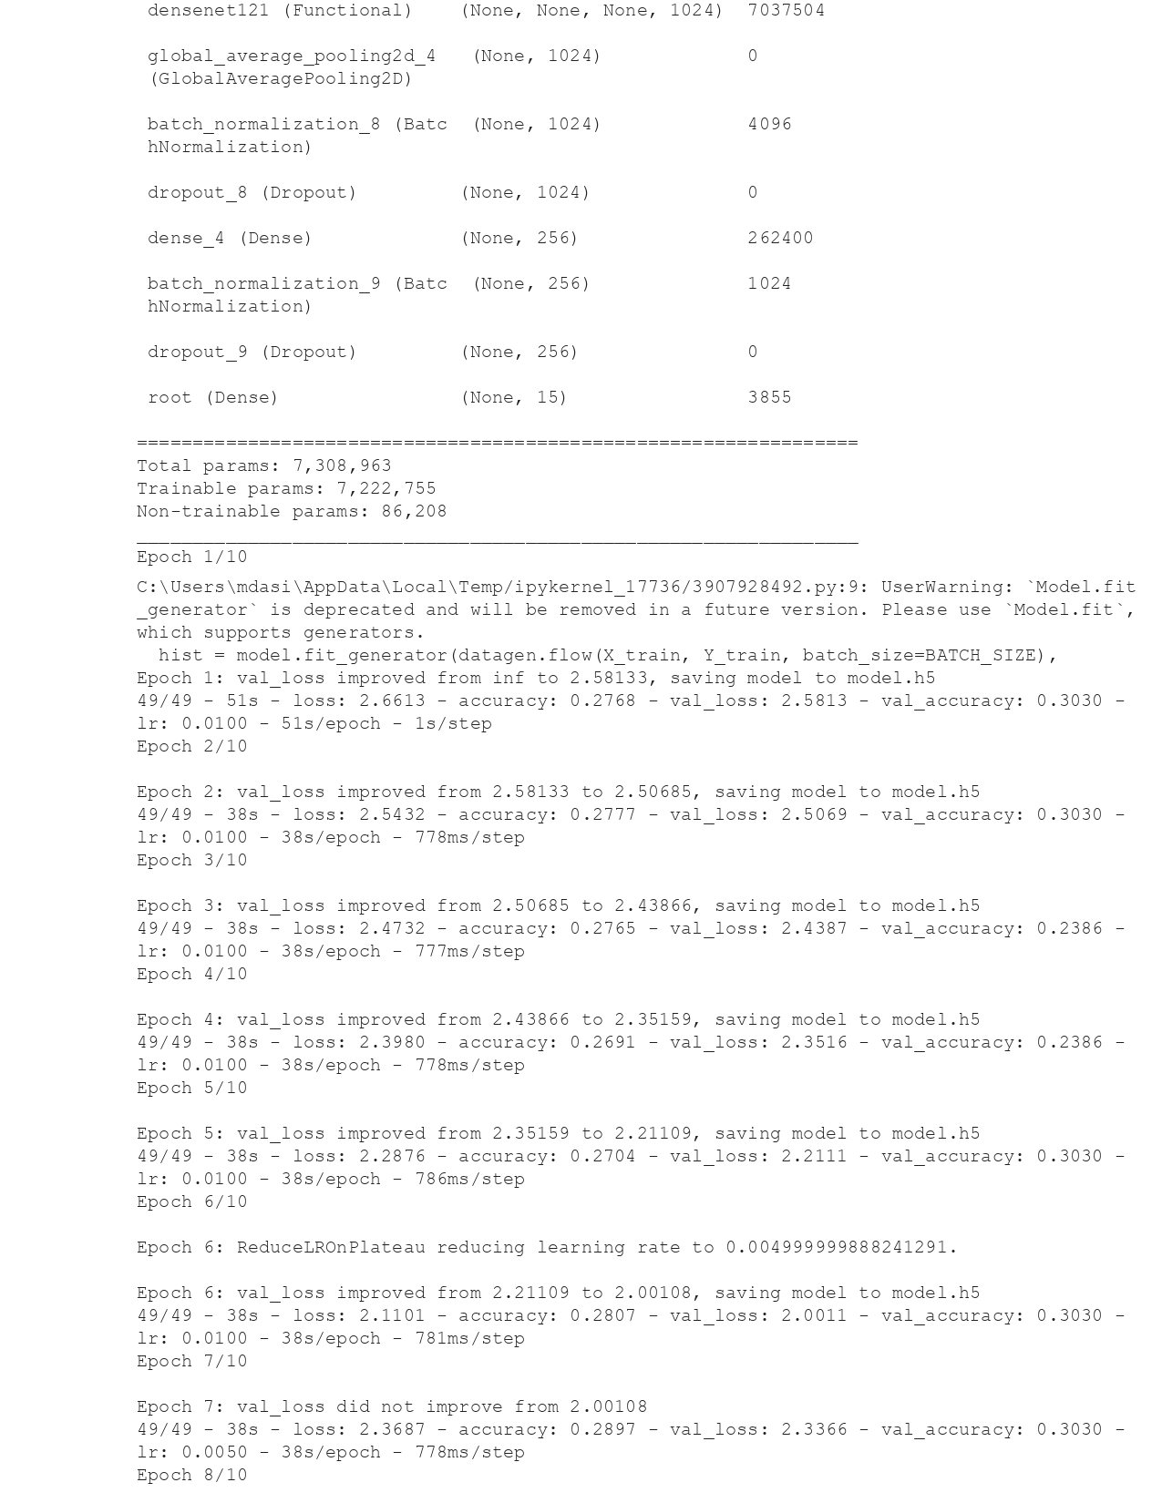

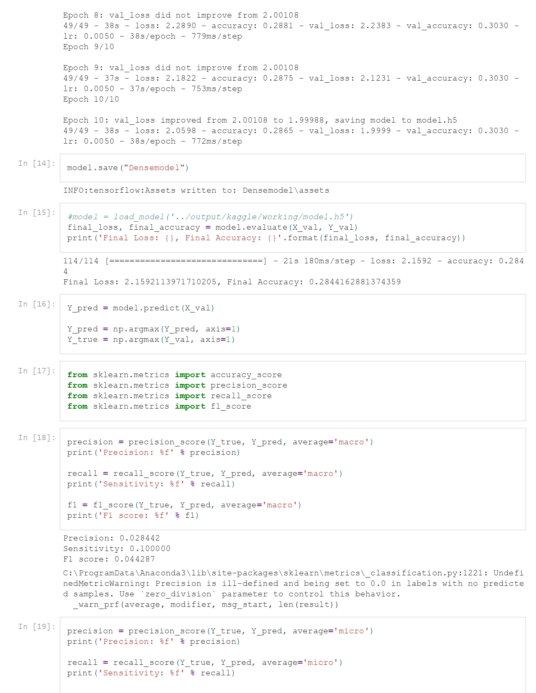

#### Code of Nadam optimizer

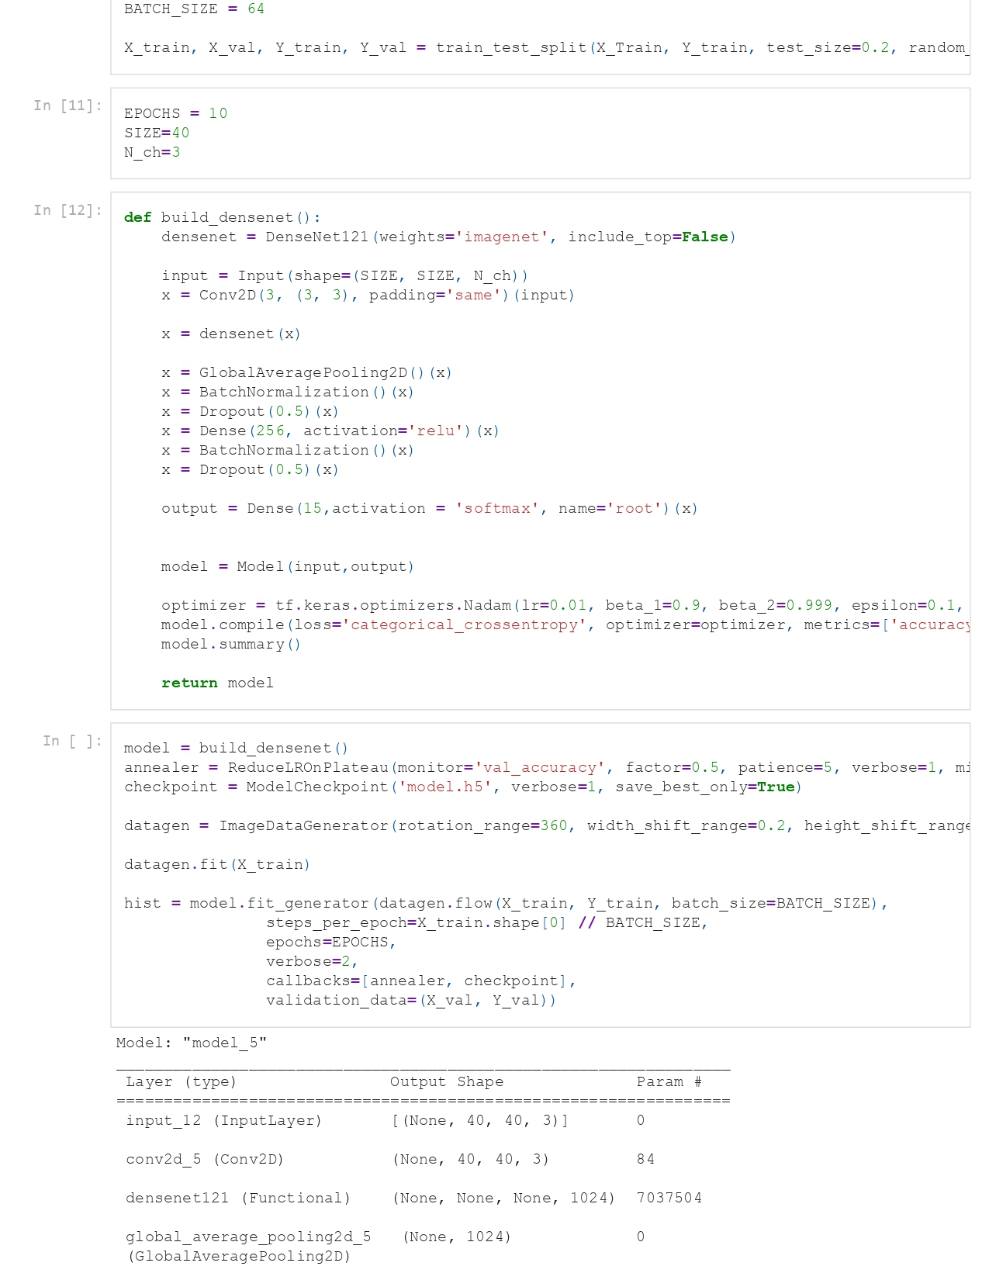

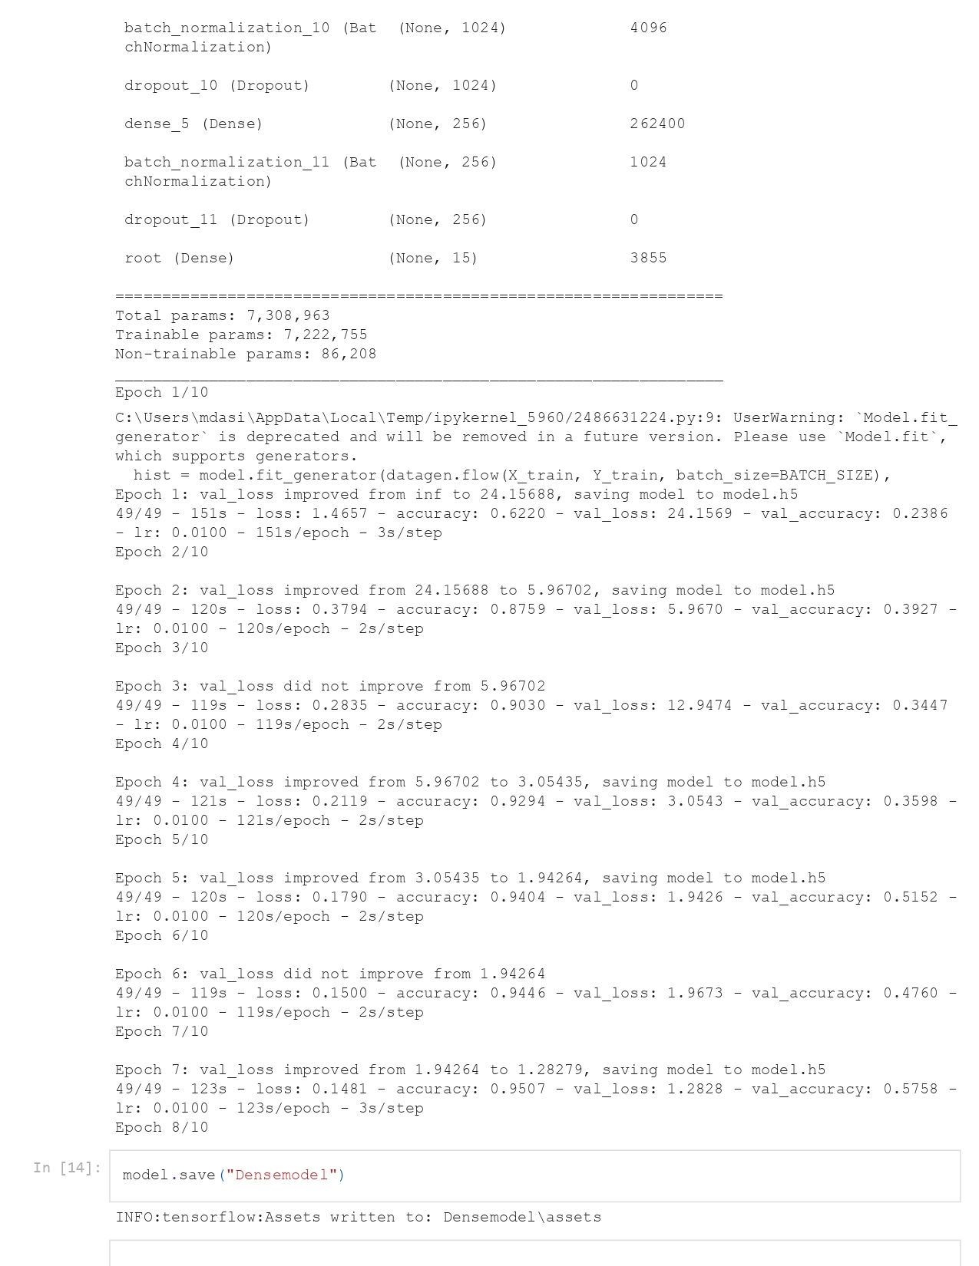

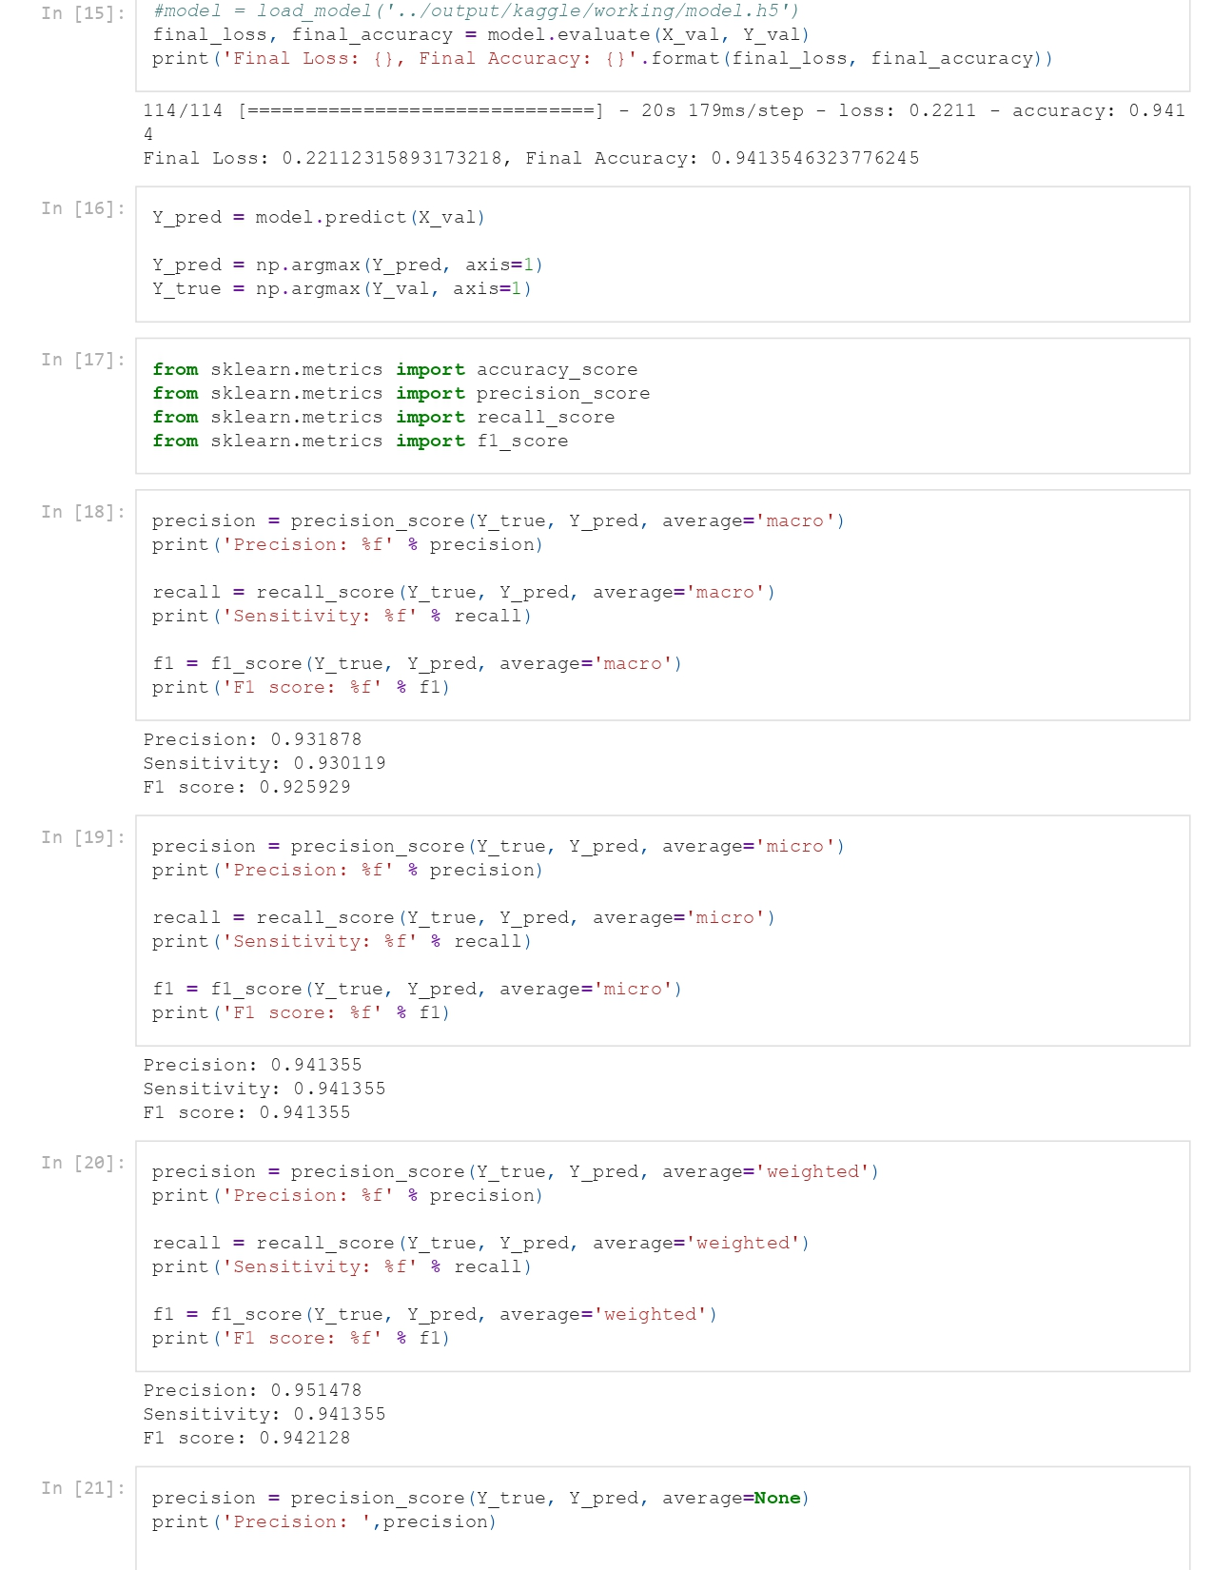

#### Code of RMSProp optimizer

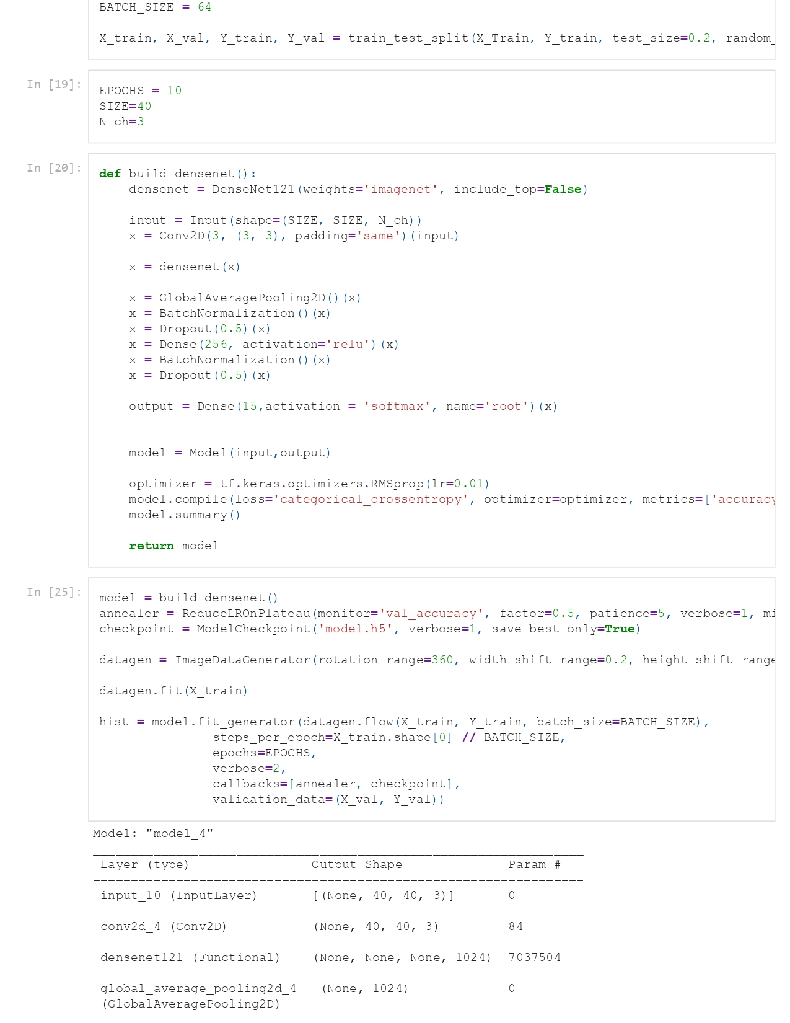

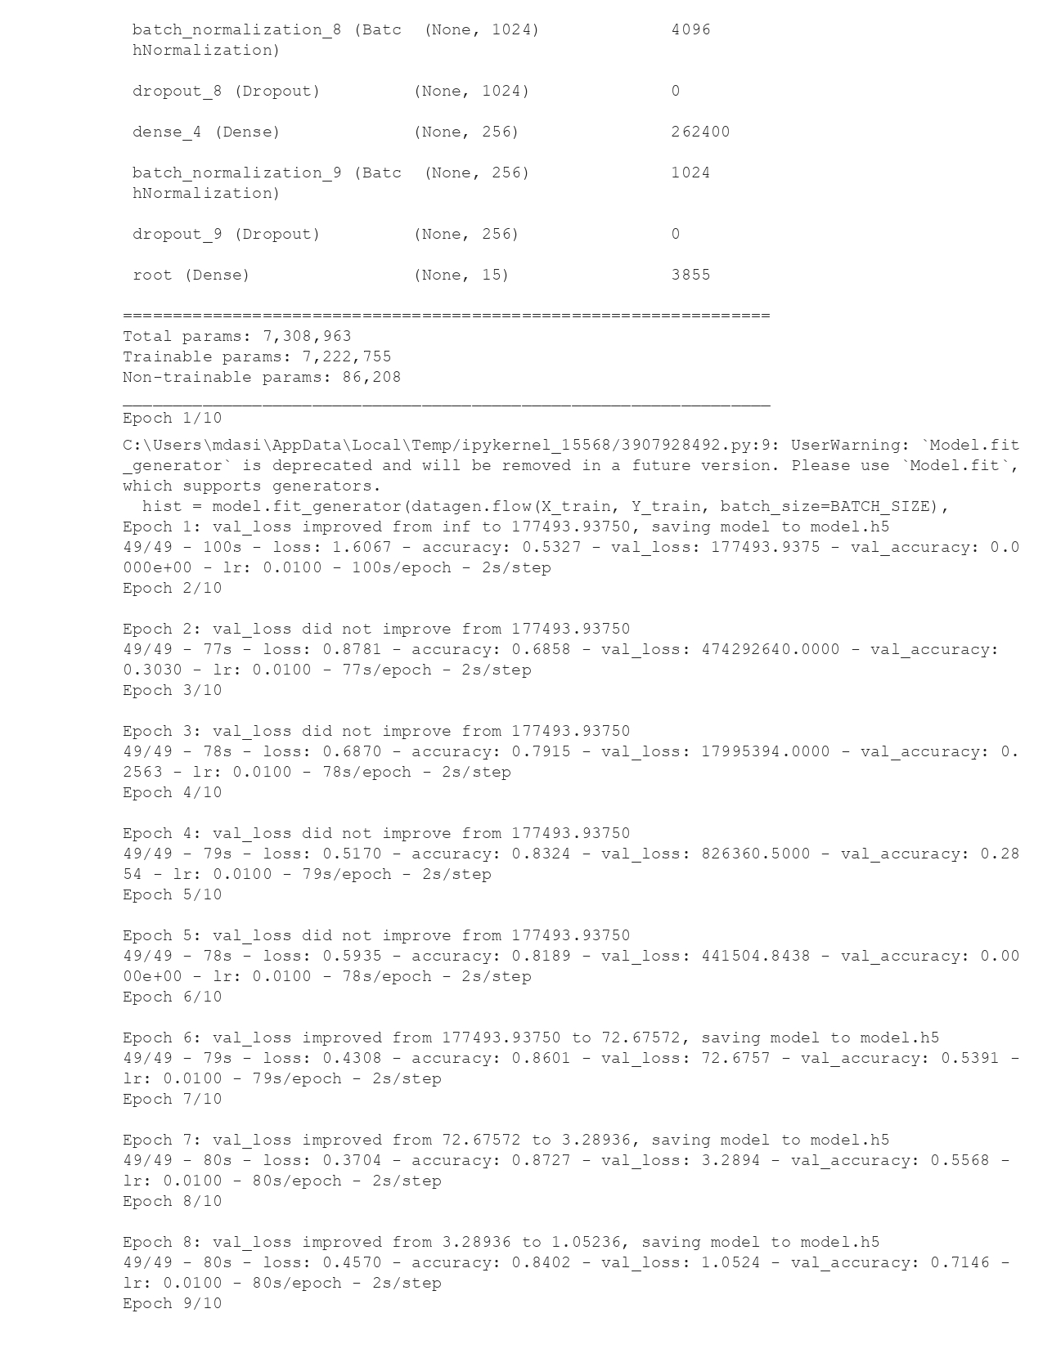

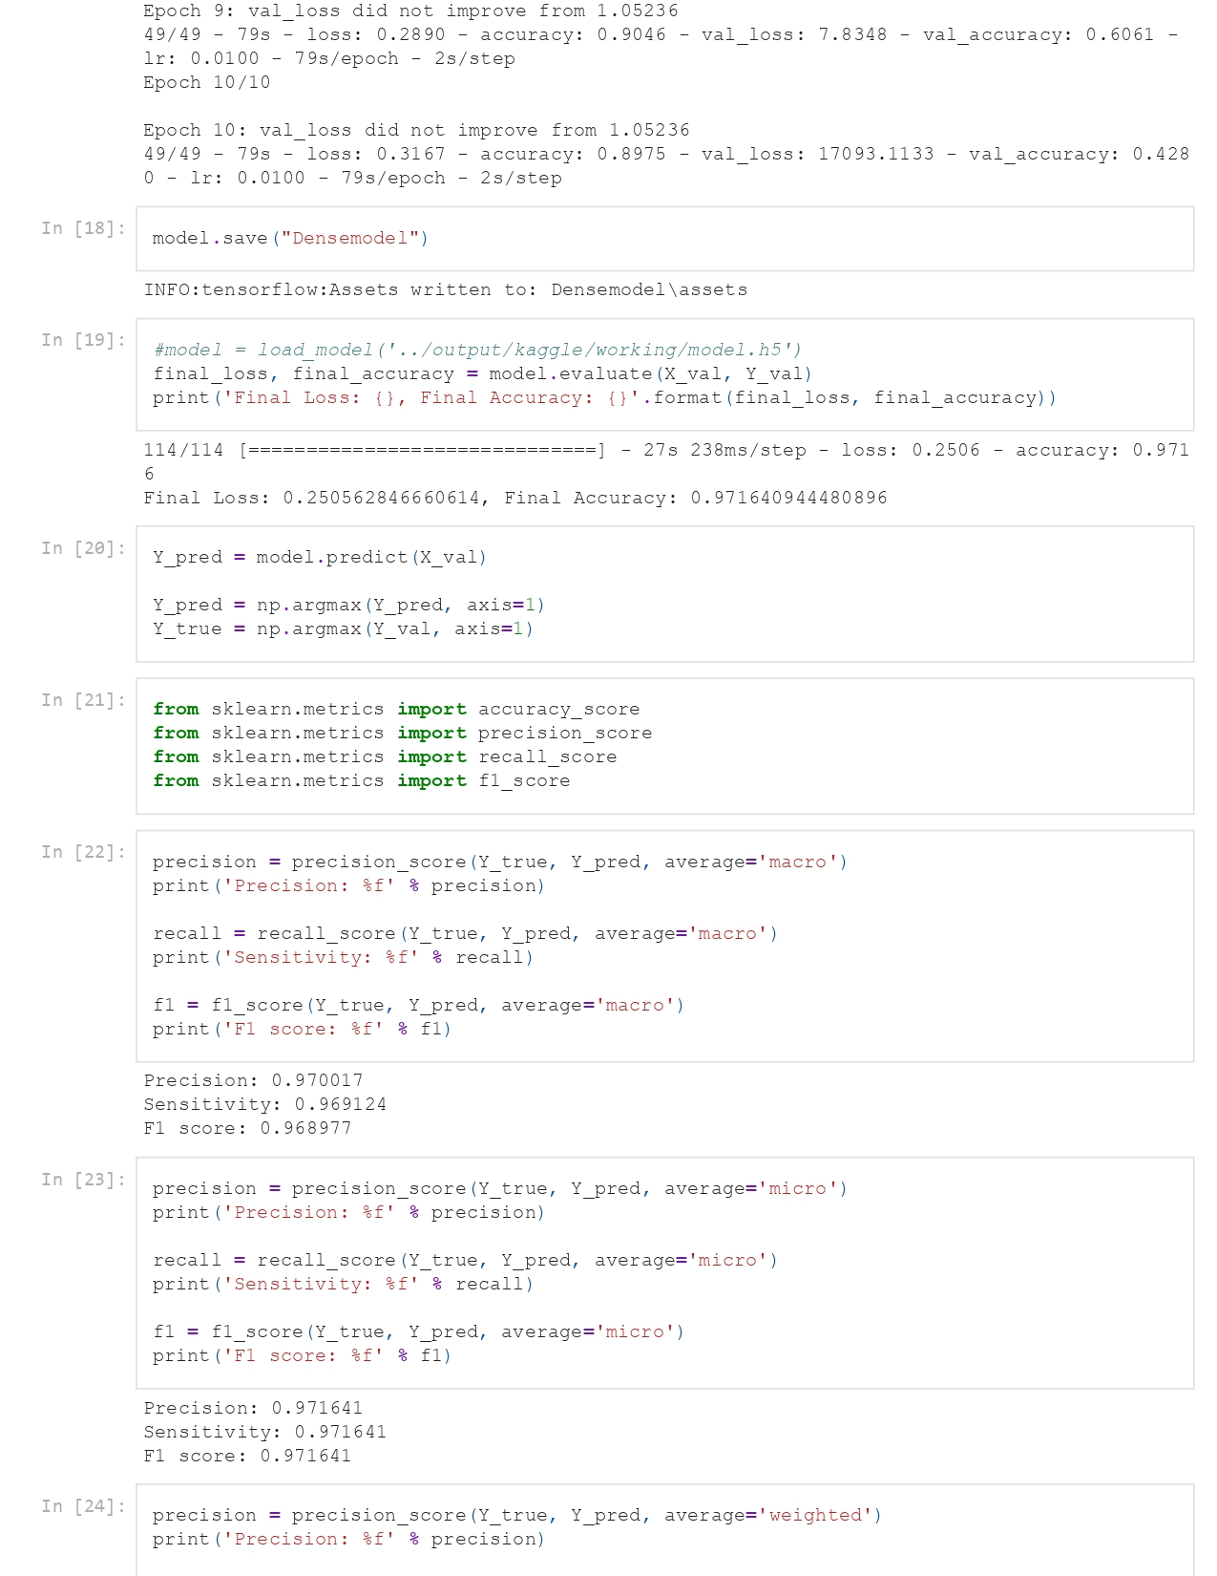

#### Code of SGD optimizer

